**Firebase Authentication for**

**Android/iOS**

# **Import Integration SDK**

Before using this template, you need to import Firebase SDK, Google Sign in SDK, Facebook SDK and Twitter SDK.

**Notes:**

* After download Firebase Authentication template, you will see like below:

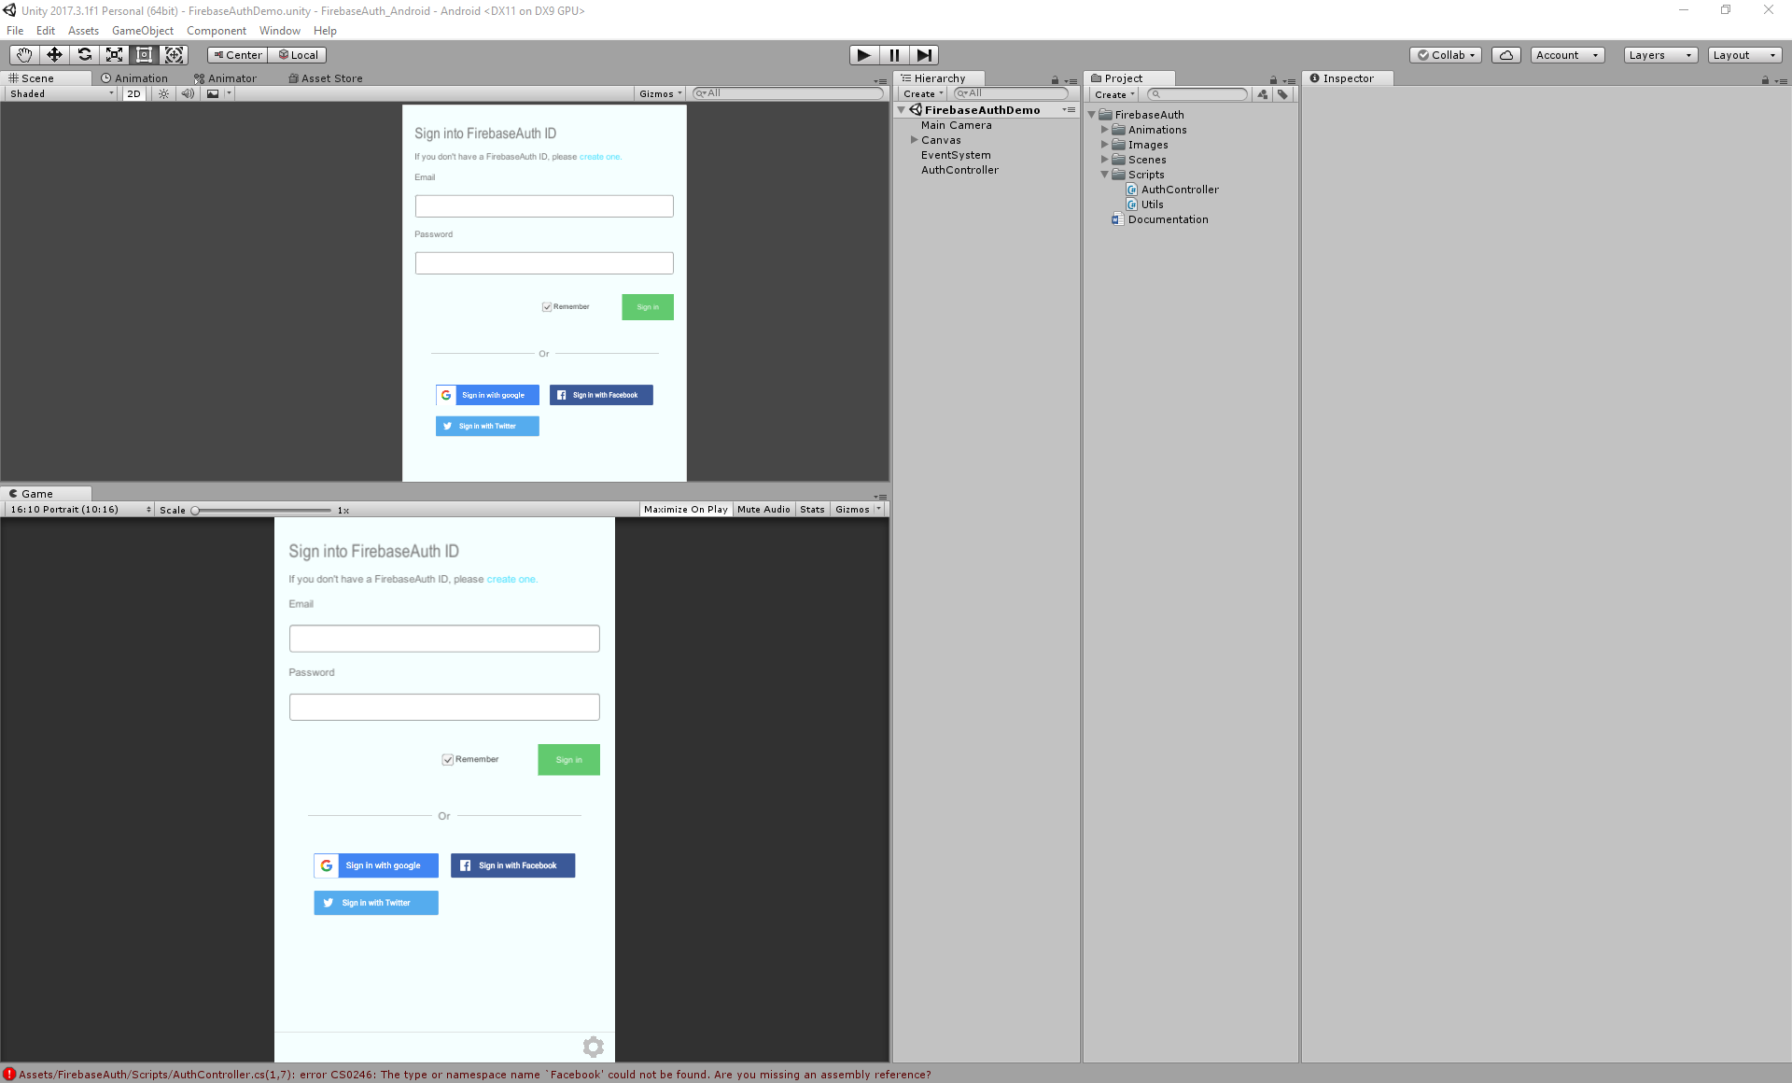

You will see some error, but don’t worry, after import SDKs, we will resolve all error.

## **Import Firebase SDK**

Click <https://firebase.google.com/download/unity> to download Firebase SDK for Unity. Extract and you will see all plugin of Firebase for Unity.

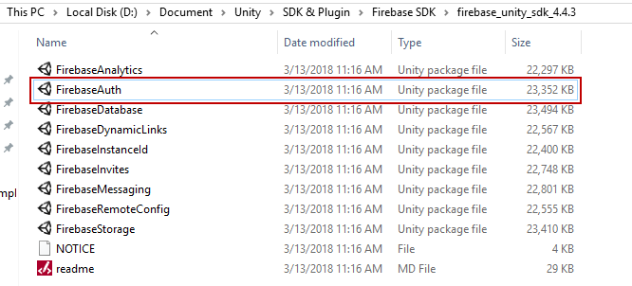

Select **Assets -> Import Package -> Custom Package…** select **FirebaseAuth** plugin to import to this template.

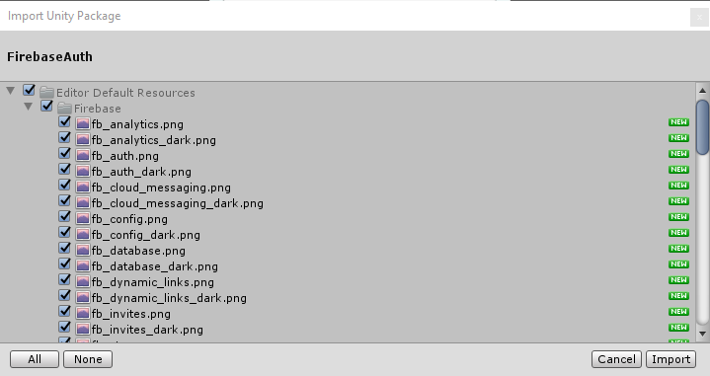

## **Import Google Sign in SDK**

Click <https://github.com/googlesamples/google-signin-unity/releases> to download Google Sign in SDK. Please download Google Sign in Plugin version 1.0.3

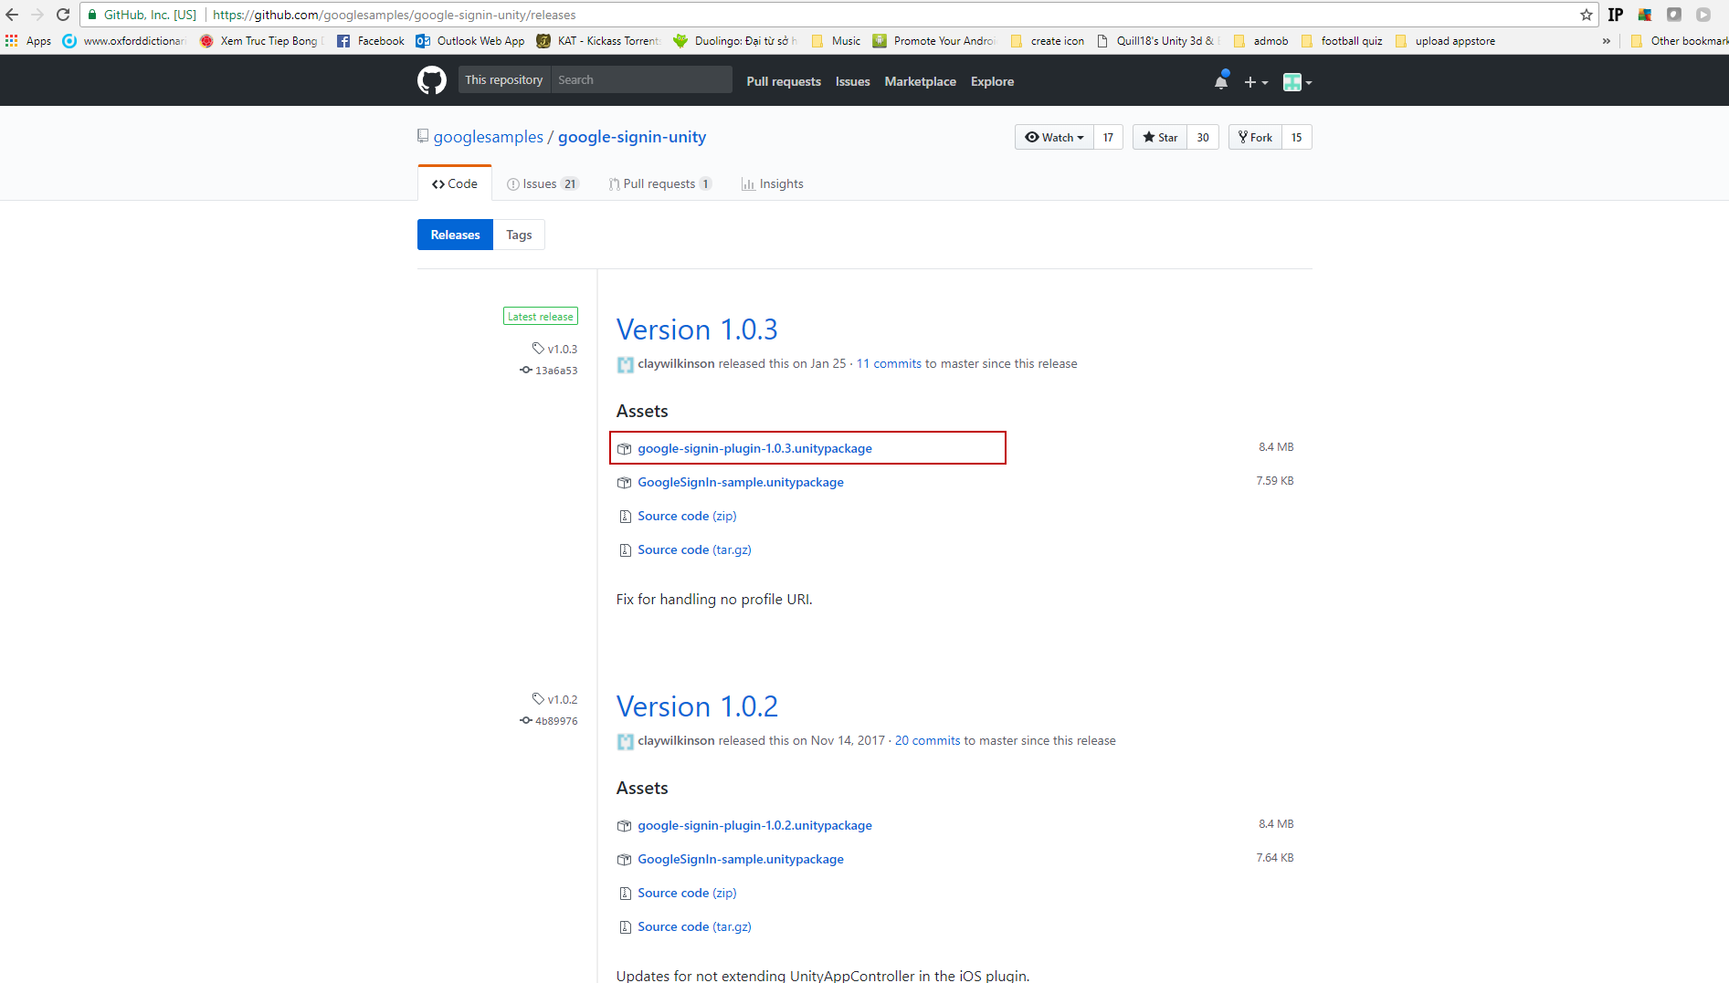

Select **Assets -> Import Package -> Custom Package…** select **google-signin-plugin-1.0.3** plugin to import to this template. Remember uncheck import **Parse** and **PlaySerrviceResolver** because we already have after import Firebase SDK.

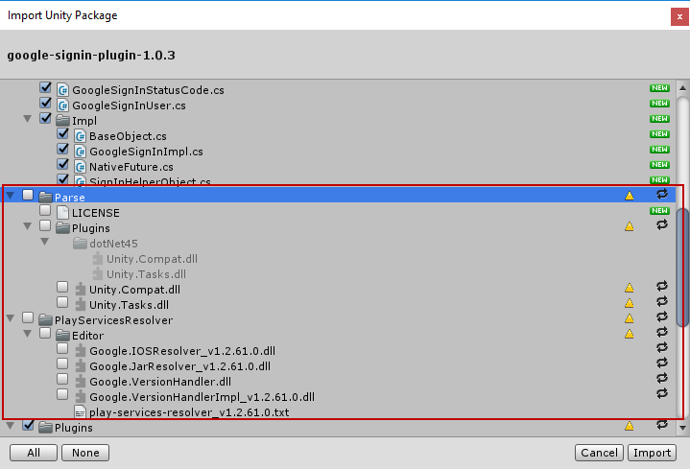

## **Import Facebook SDK**

Click <https://developers.facebook.com/docs/unity/downloads> to download Facebook SDK. Please download Facebook SDK 7.13.0(Because you can get some error with other verions).

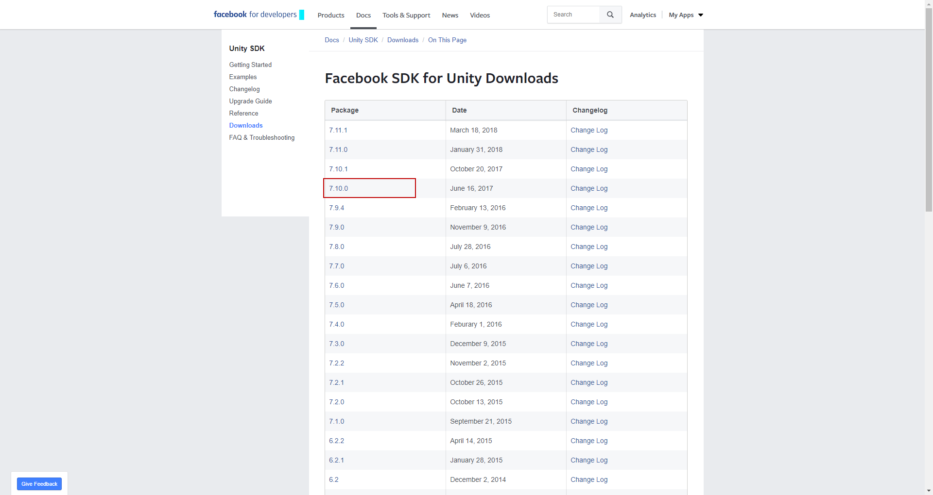

Select **Assets -> Import Package -> Custom Package…** select **facebook-unity-sdk-7.10.0** plugin to import to this template. Remember uncheck import **PlaySerrviceResolver** like image below because some dll we already have after import Firebase SDK and Google Sign in SDK.

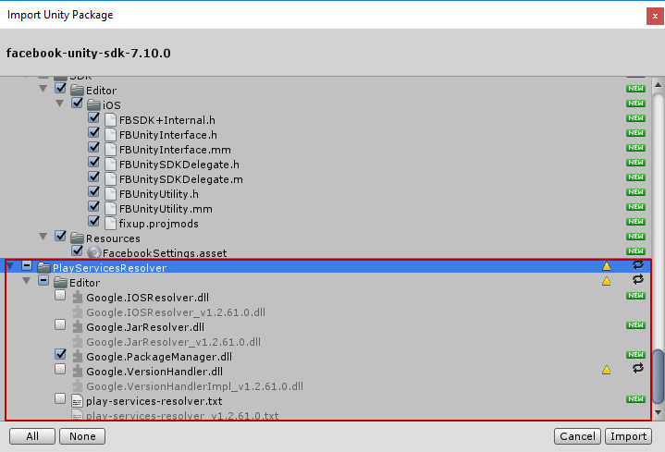

## **Import Twitter Kit SDK**

Open **Asset Store** window.

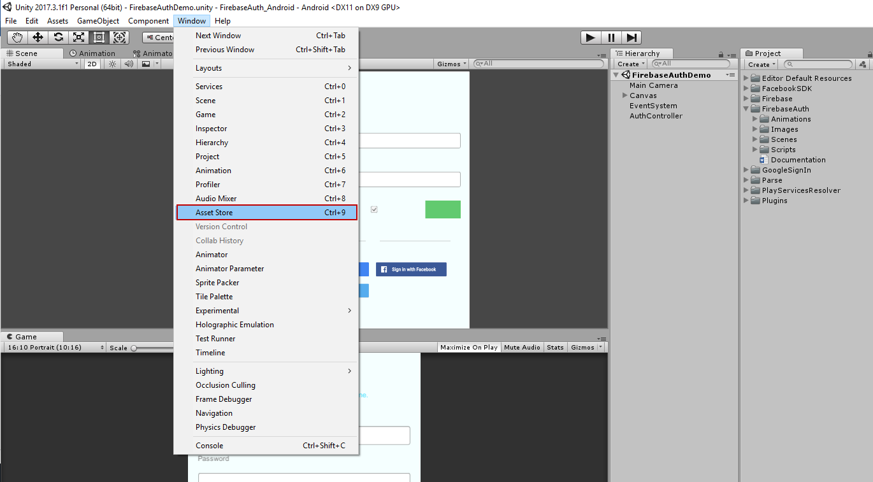

Search **Twitter Kit SDK -> Import** to template.

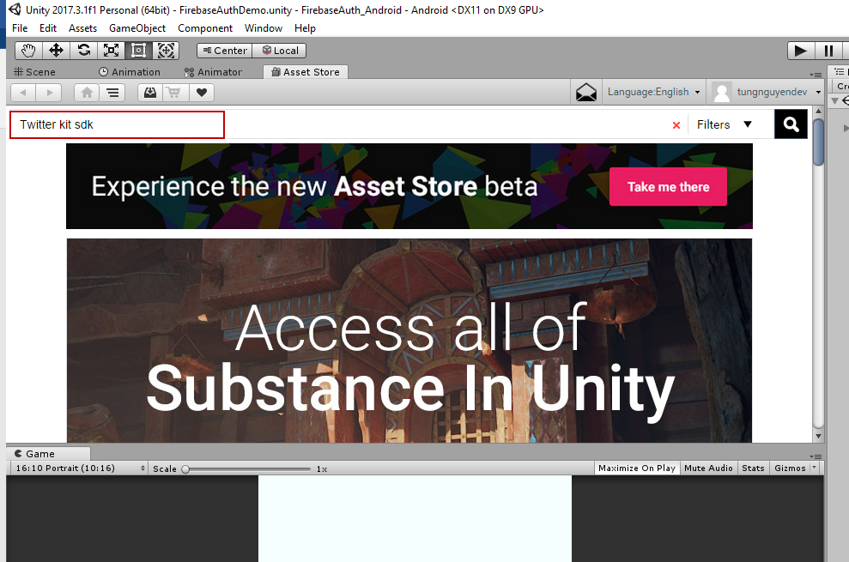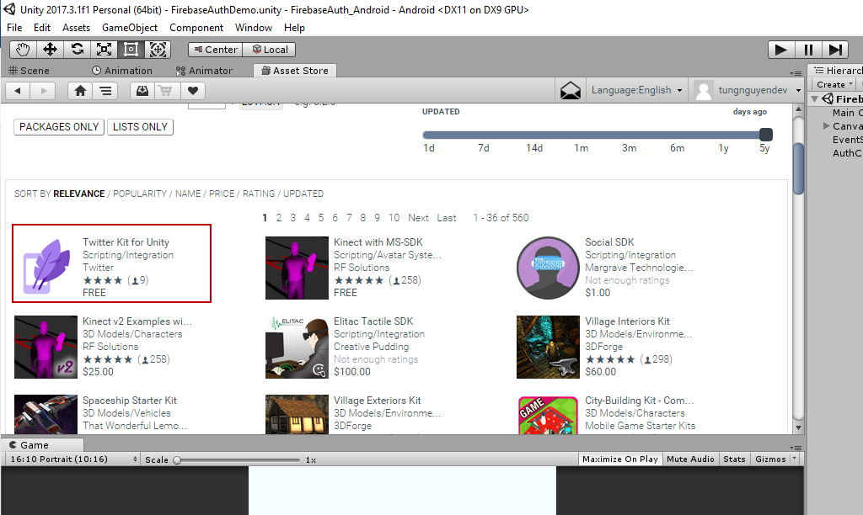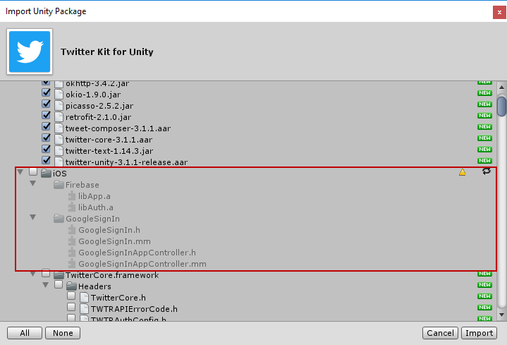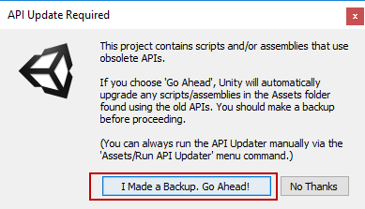

## **Clear Error**

Open **Console** tab and **Clear** all error.

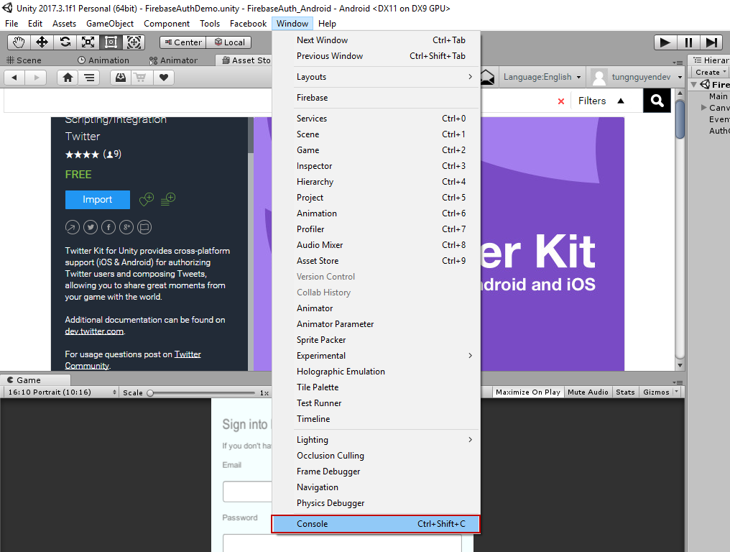

And you will see like that

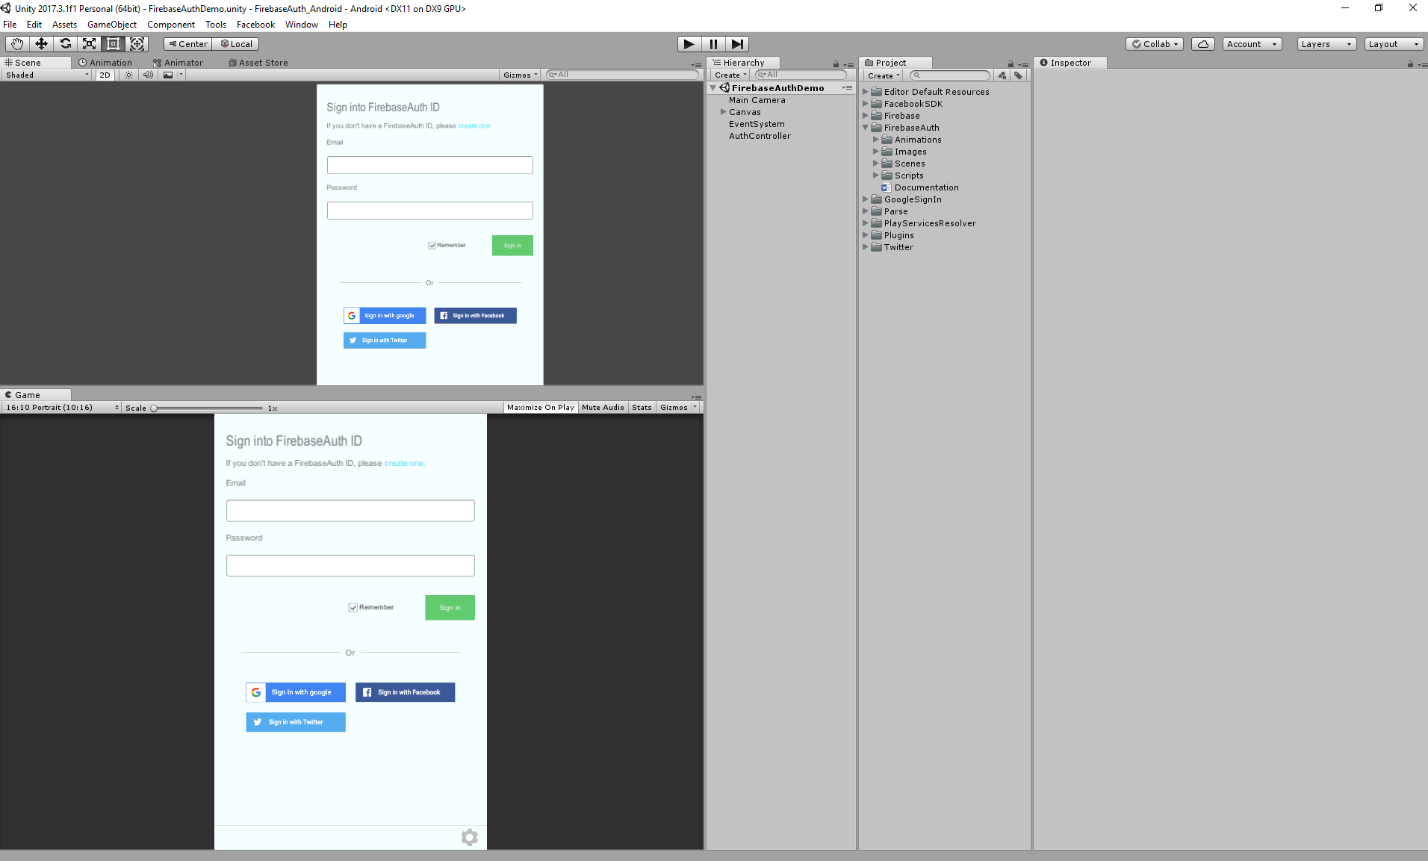

# **Setting Environment (Android Only)**

## **OpenSSL**

Download: <https://code.google.com/archive/p/openssl-for-windows/downloads>

Extract and configure on System Environment:

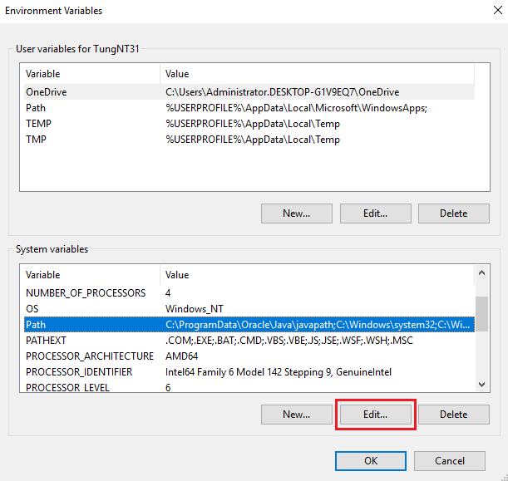

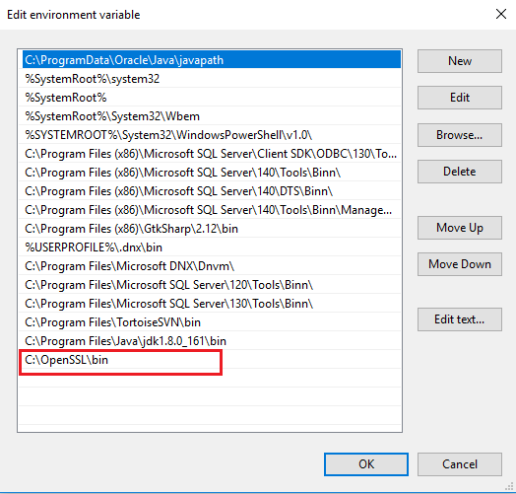

## **JDK**

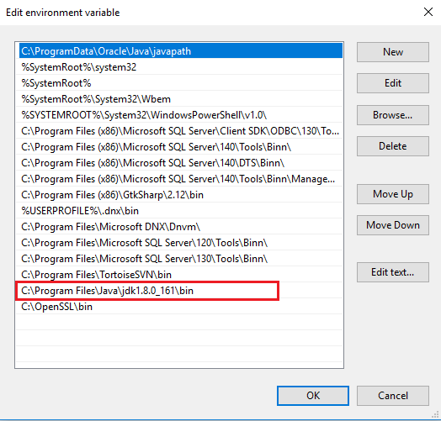

## **Notes**

* In the case you don’t have debug.keystore on **C:\Users\[YOUR PC NAME]\.android** and Unity will display as below:

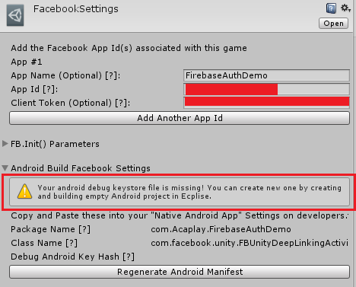

Please create new debug.keystore as below:

CMD(run with admin) -> Go to JDK bin folder and run

keytool -genkey -v -keystore "%USERPROFILE%\.android\debug.keystore" -alias androiddebugkey -storepass android -keypass android -keyalg RSA -validity 30000

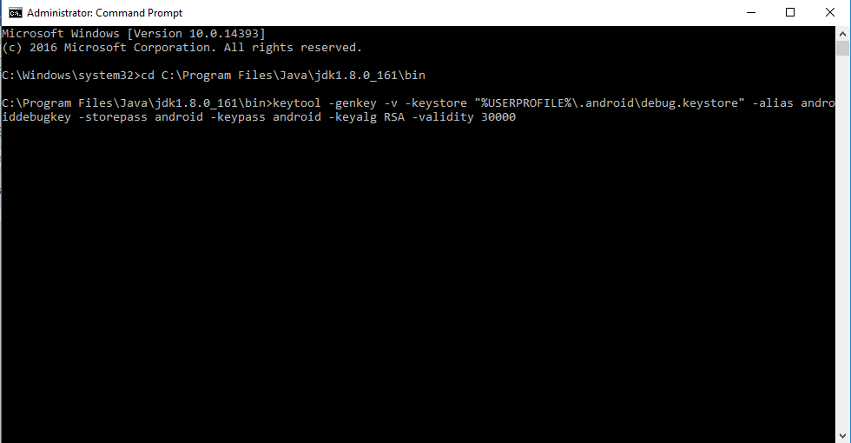

Input your information to complete creating. When you completed, the warning will disable.

# **Setup Firebase**

Go to <https://console.firebase.google.com/> and create new project.

On Welcome screen, click **Add Project.**

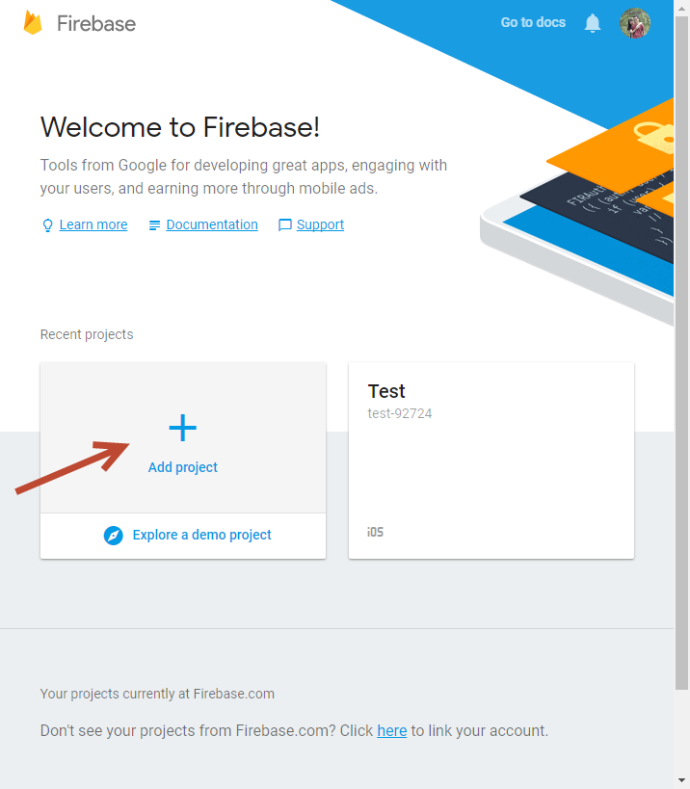

Input information and click **Create Project.**

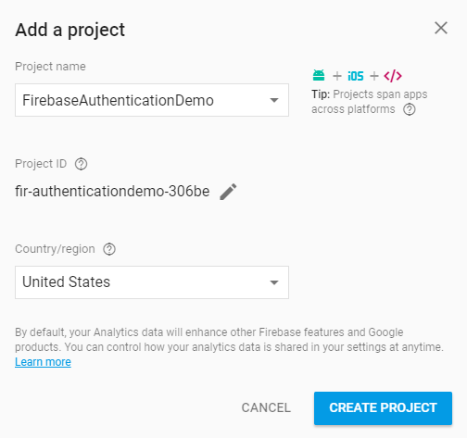

## **Setup for iOS**

Click **Add Firebase to your iOS app.**

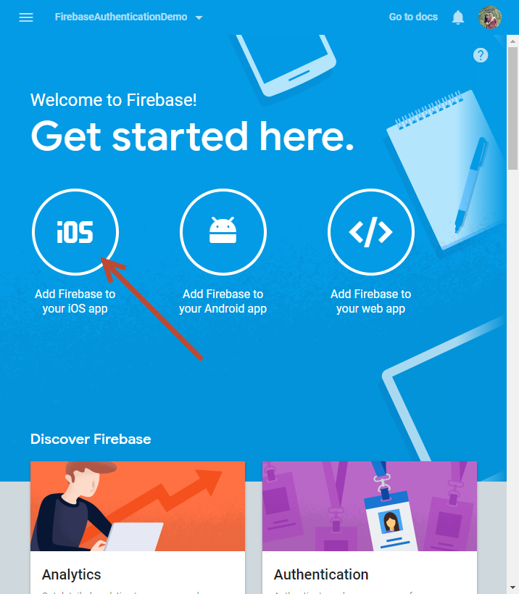

Input iOS bundle ID (get from Unity project) and click **Register App**.

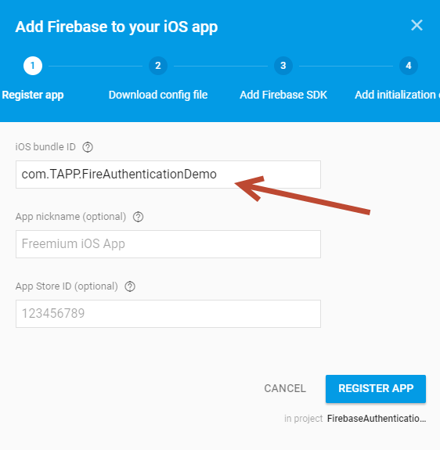

Download configuration file and drag to Unity Project, click **Continue**.

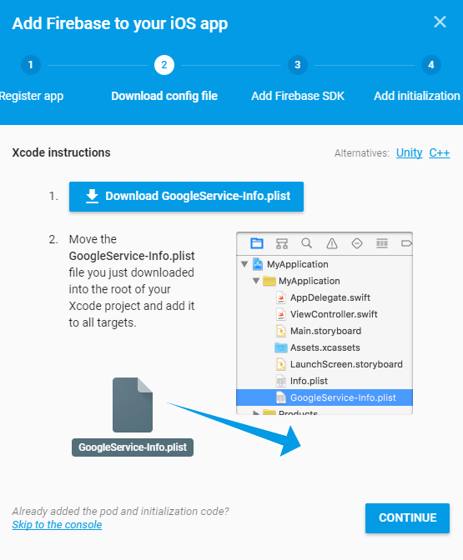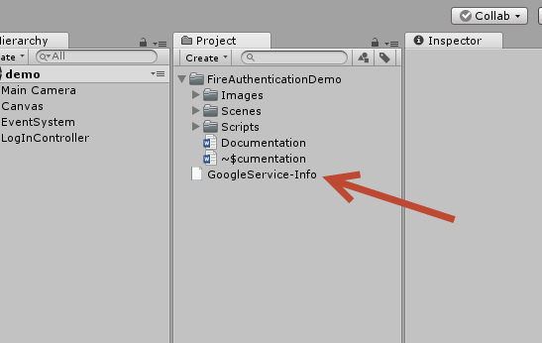

Because we are working with Unity, so click **Continue** toskip step 3.

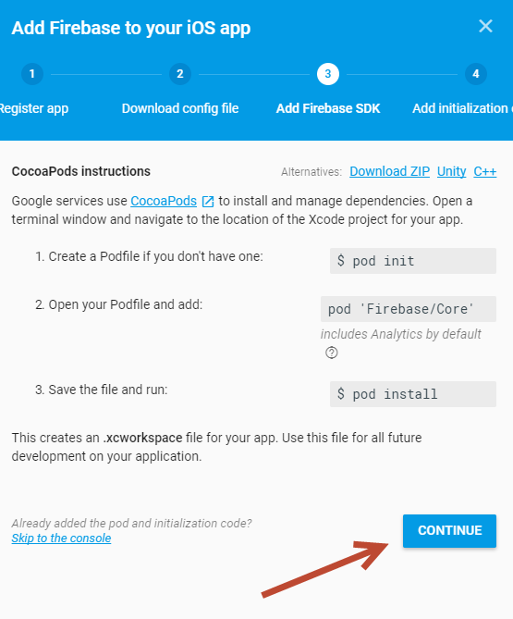

The same for step 4,click **Finish**.

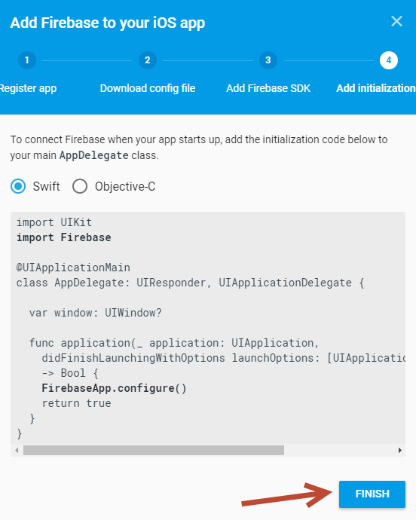

## **Setup for Android**

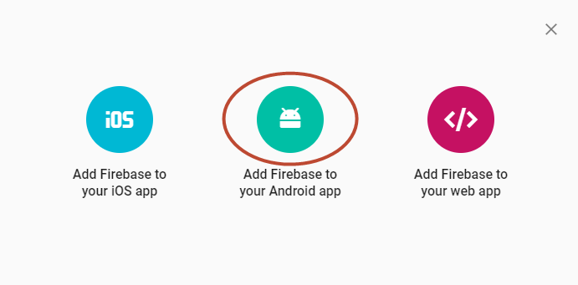

Input Android bundle ID (get from Unity project and please note, your bundle Id is never used before), nick name, and SHA-1 debug certificate.

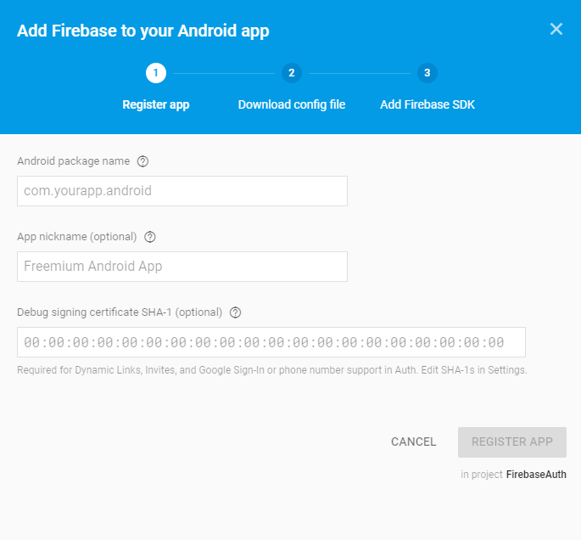

Get Debug signing certificate SHA-1, follow link: <https://acareddit.blogspot.com/2018/01/how-to-get-signing-certificate.html>

Download Configuration file and drag to your Unity Project.

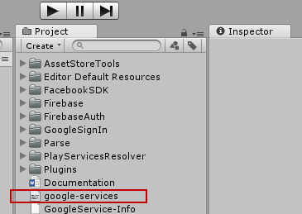

## **Enable Sign-In Method**

Click **Authentication** on left menu.

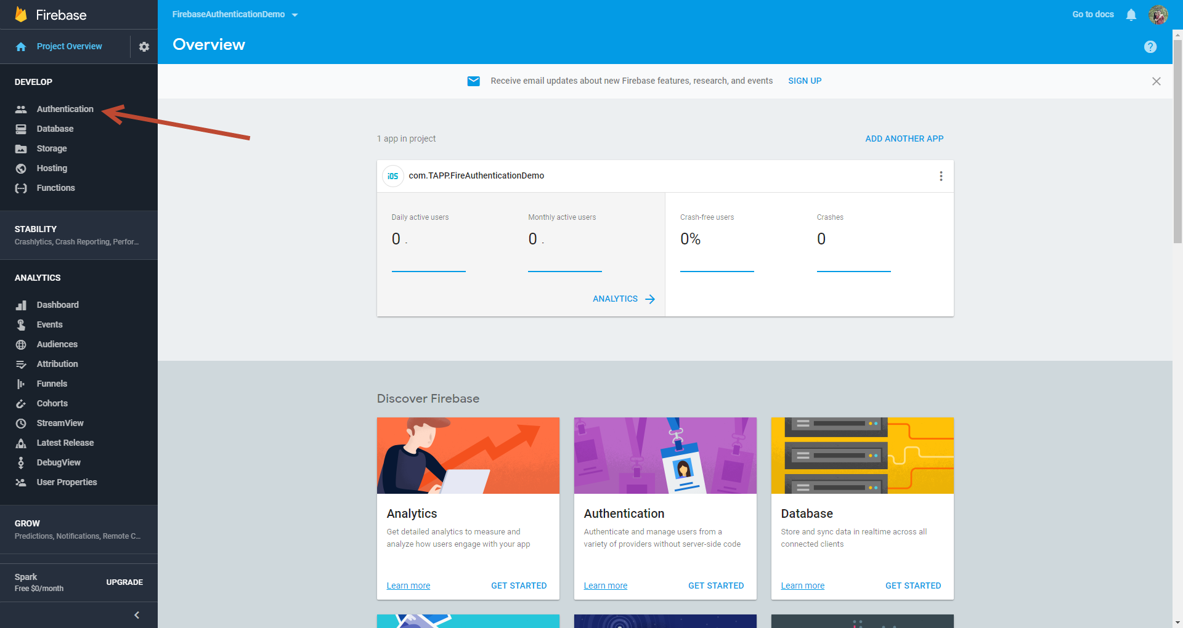

Click **Sign-In Method** tab

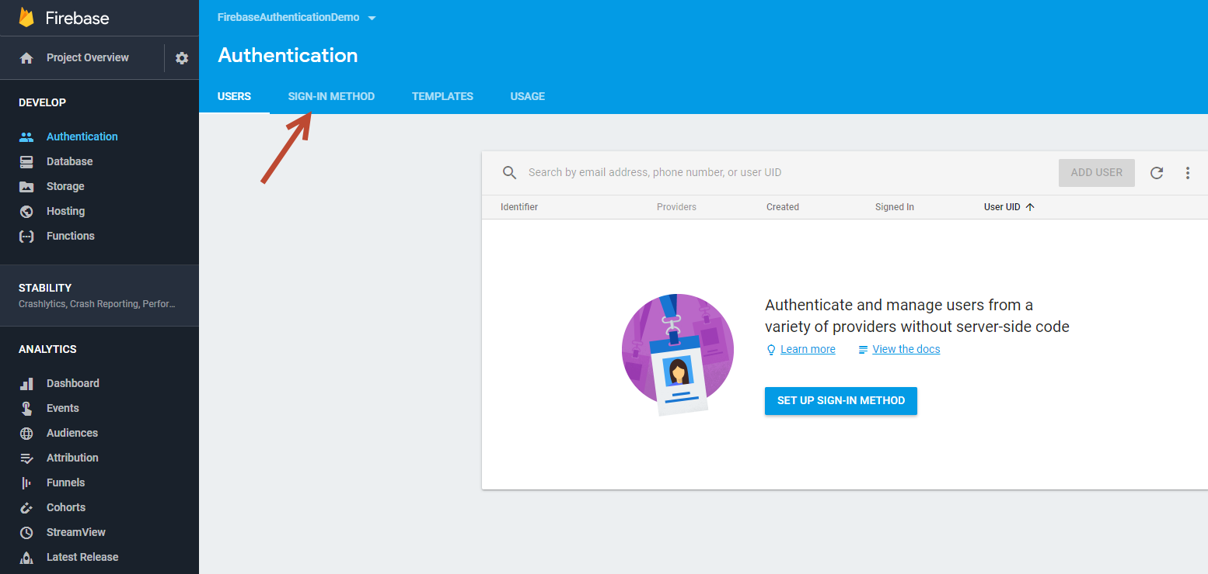

Enable **Email Pwd,** **Google**, **Facebook (**refer **3. Setup Facebook** to get **App ID** and **App Secret)**, **Twitter** (refer 4) method.

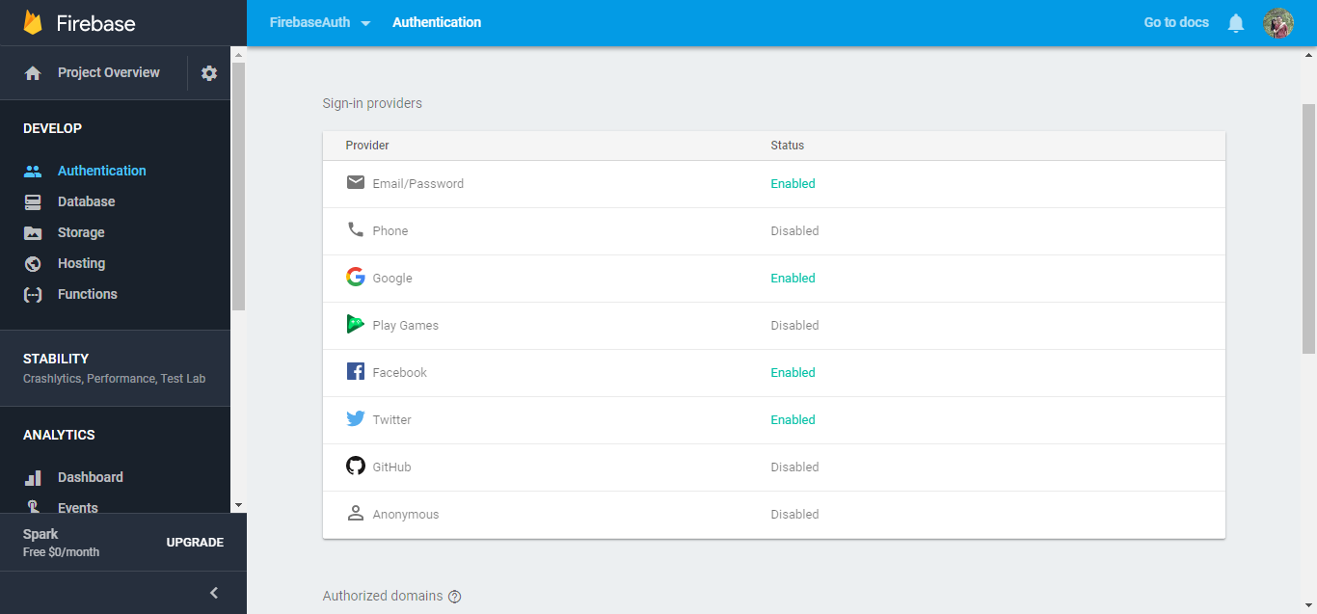

# **Setup Facebook**

Go to <https://developers.facebook.com/> and click **Add New App.**

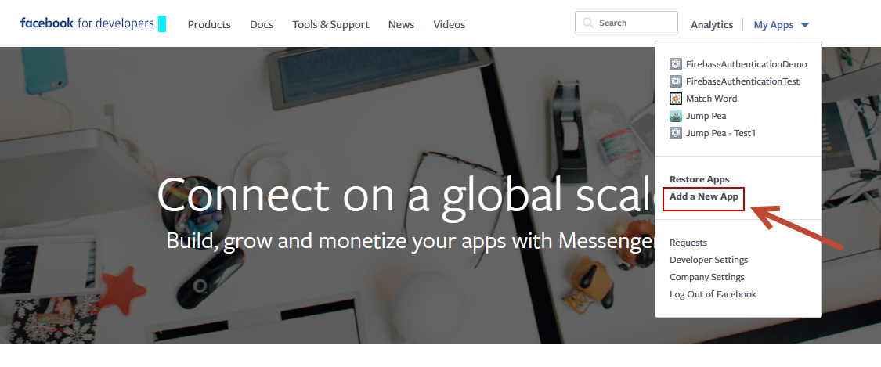

Input project information and click Create App ID

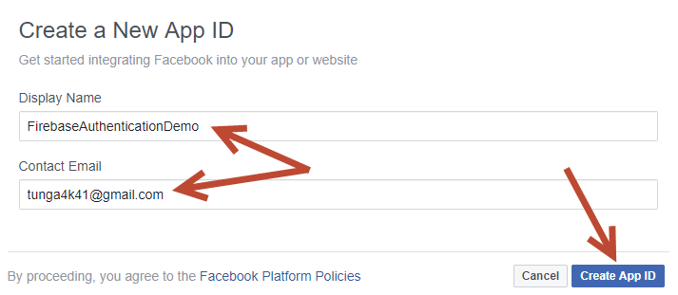

Verify you are not robot ☺

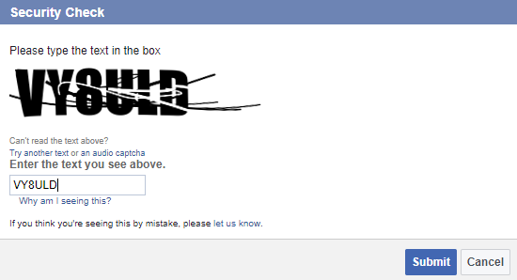

Select **Facebook Login** product

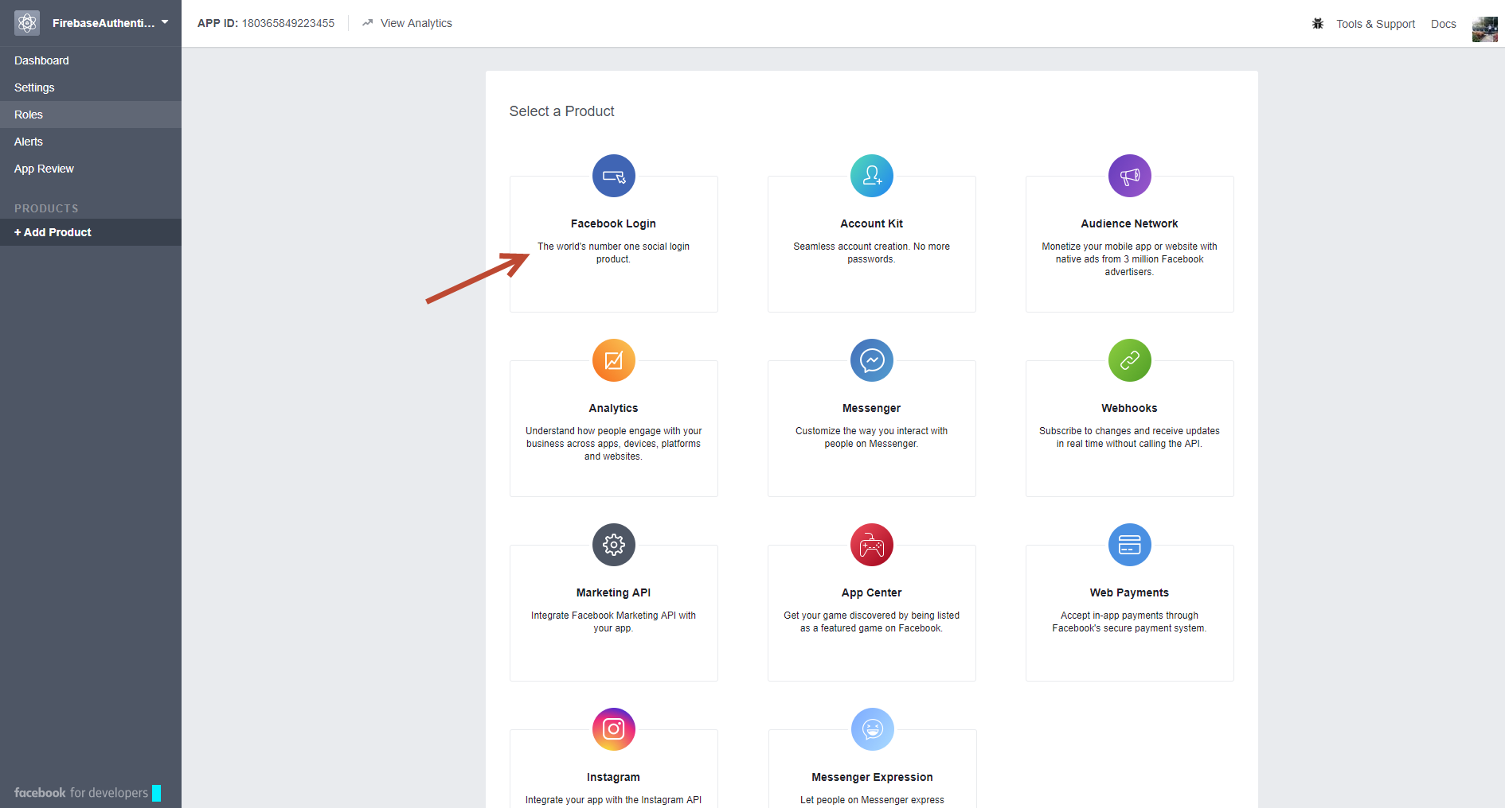

And click **Dashboard** (don’t care anything)**.**

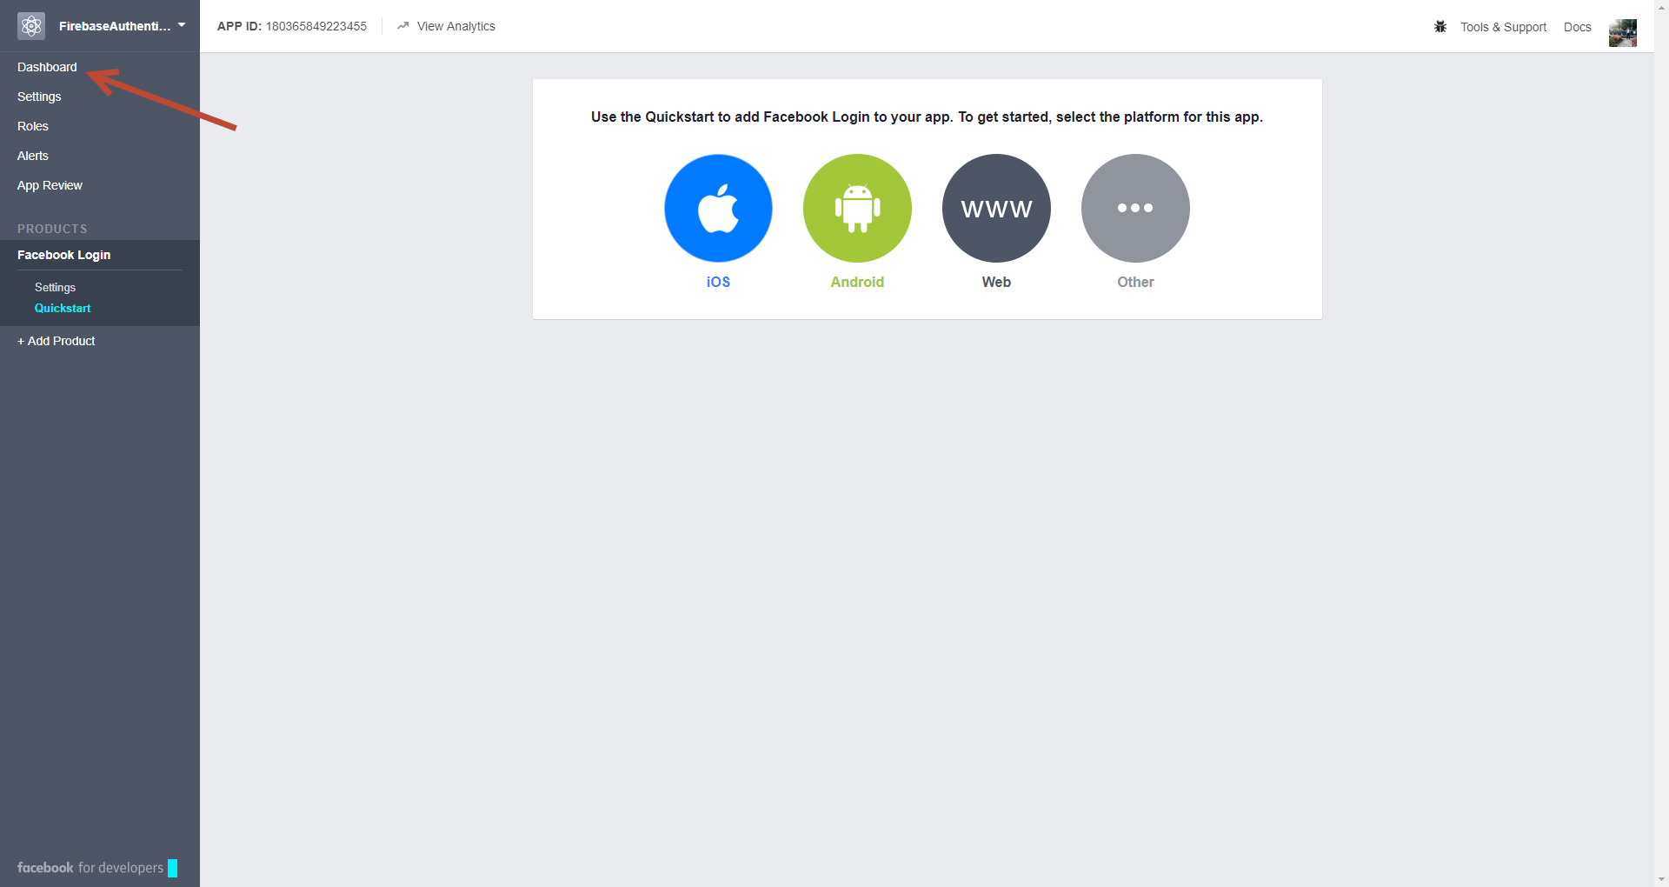

Now we have **App ID** and **App Secret** to input to **Firebase Setup**.

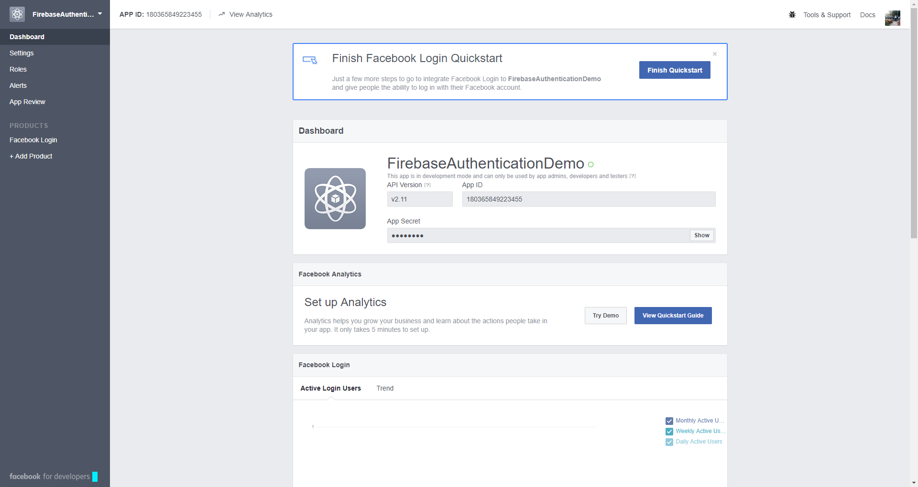

Input **App ID, App Secret** to finish **Firebase Facebook Login**.

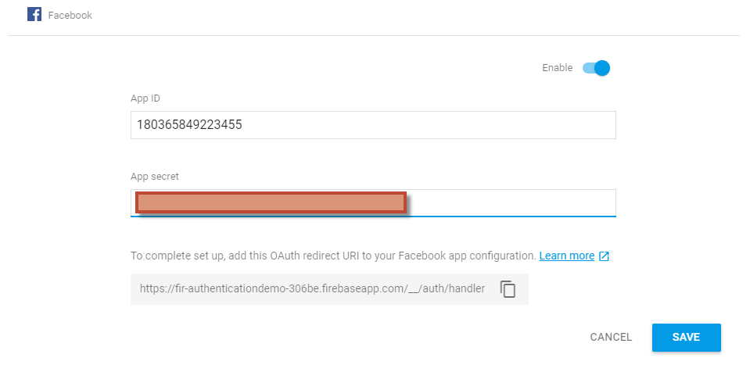

Click **Facebook Login -> Setting.**

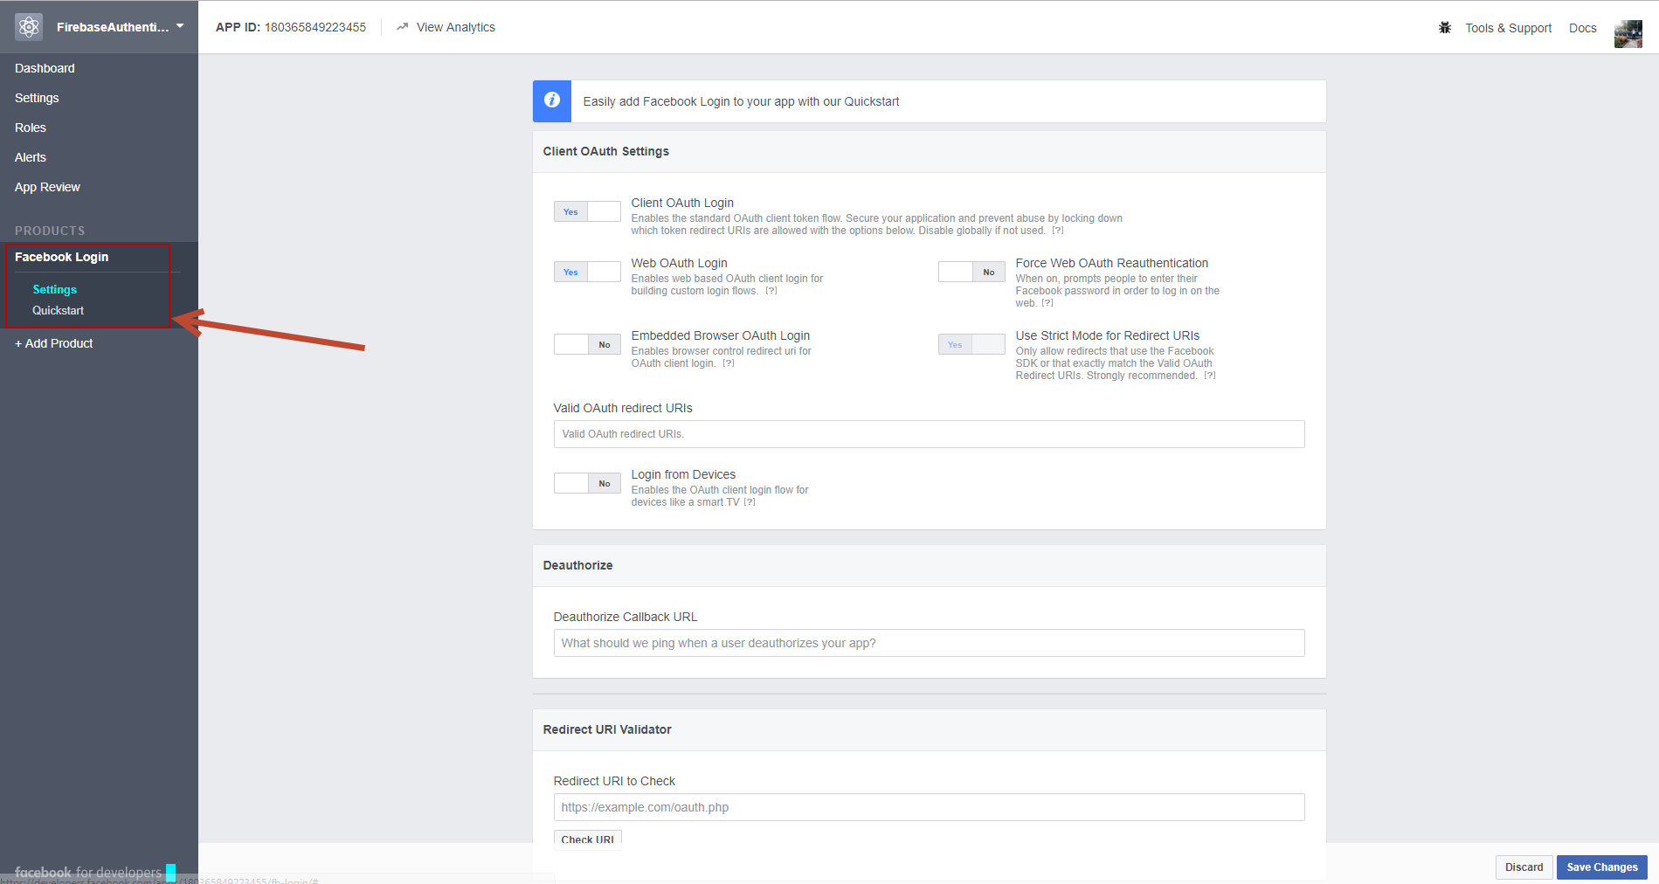

Copy OAuth redirect URI from Firebase Facebook setup and put to Valid OAuth redirect URIs -> **Save**.

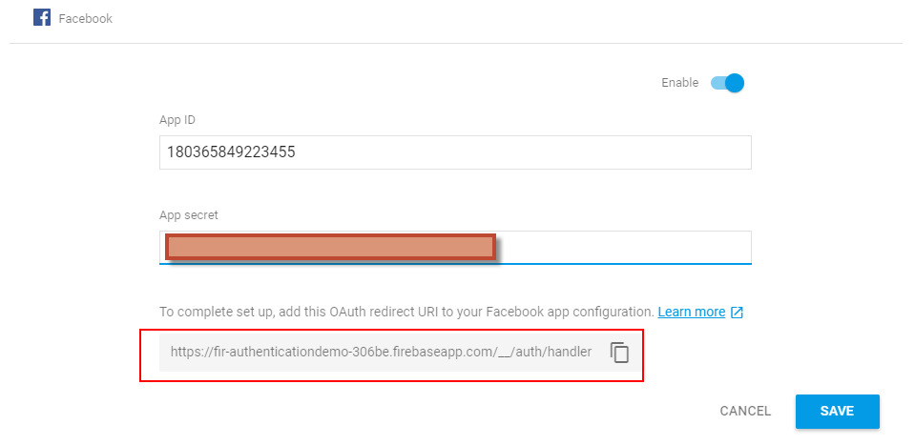

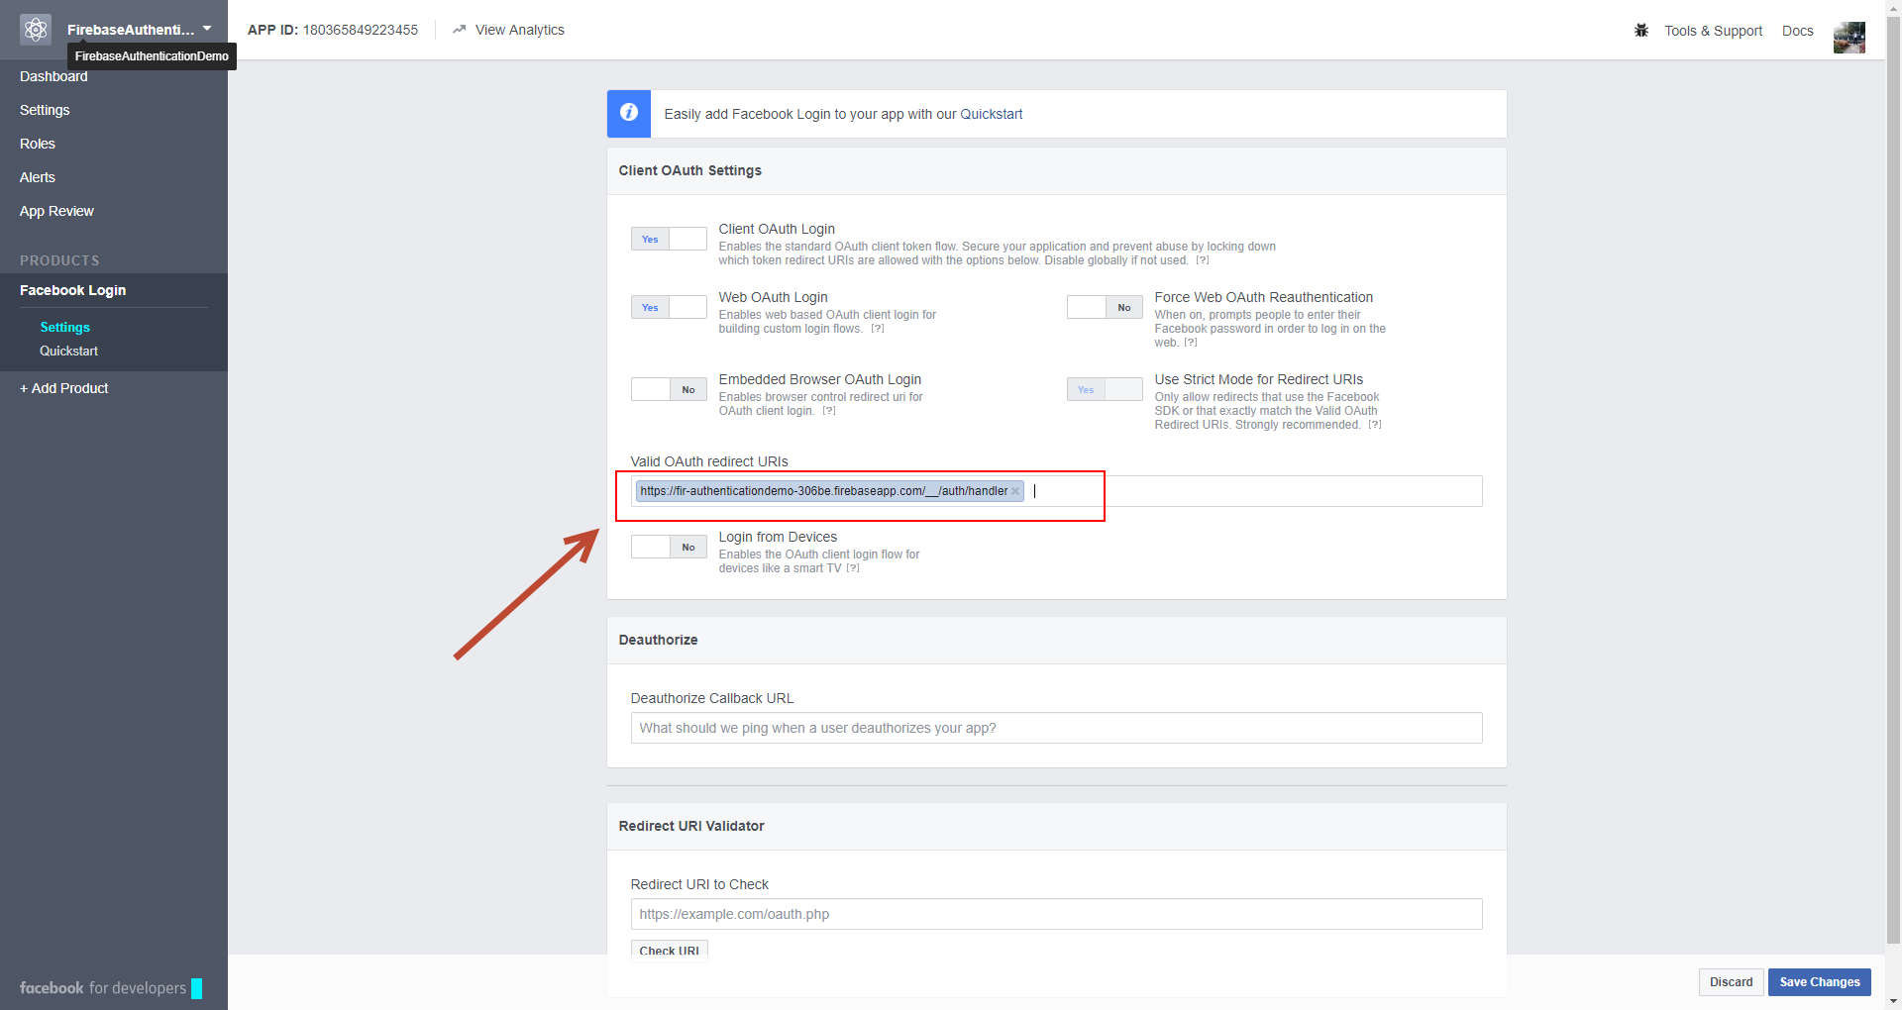

Click **Setting -> Basic.**

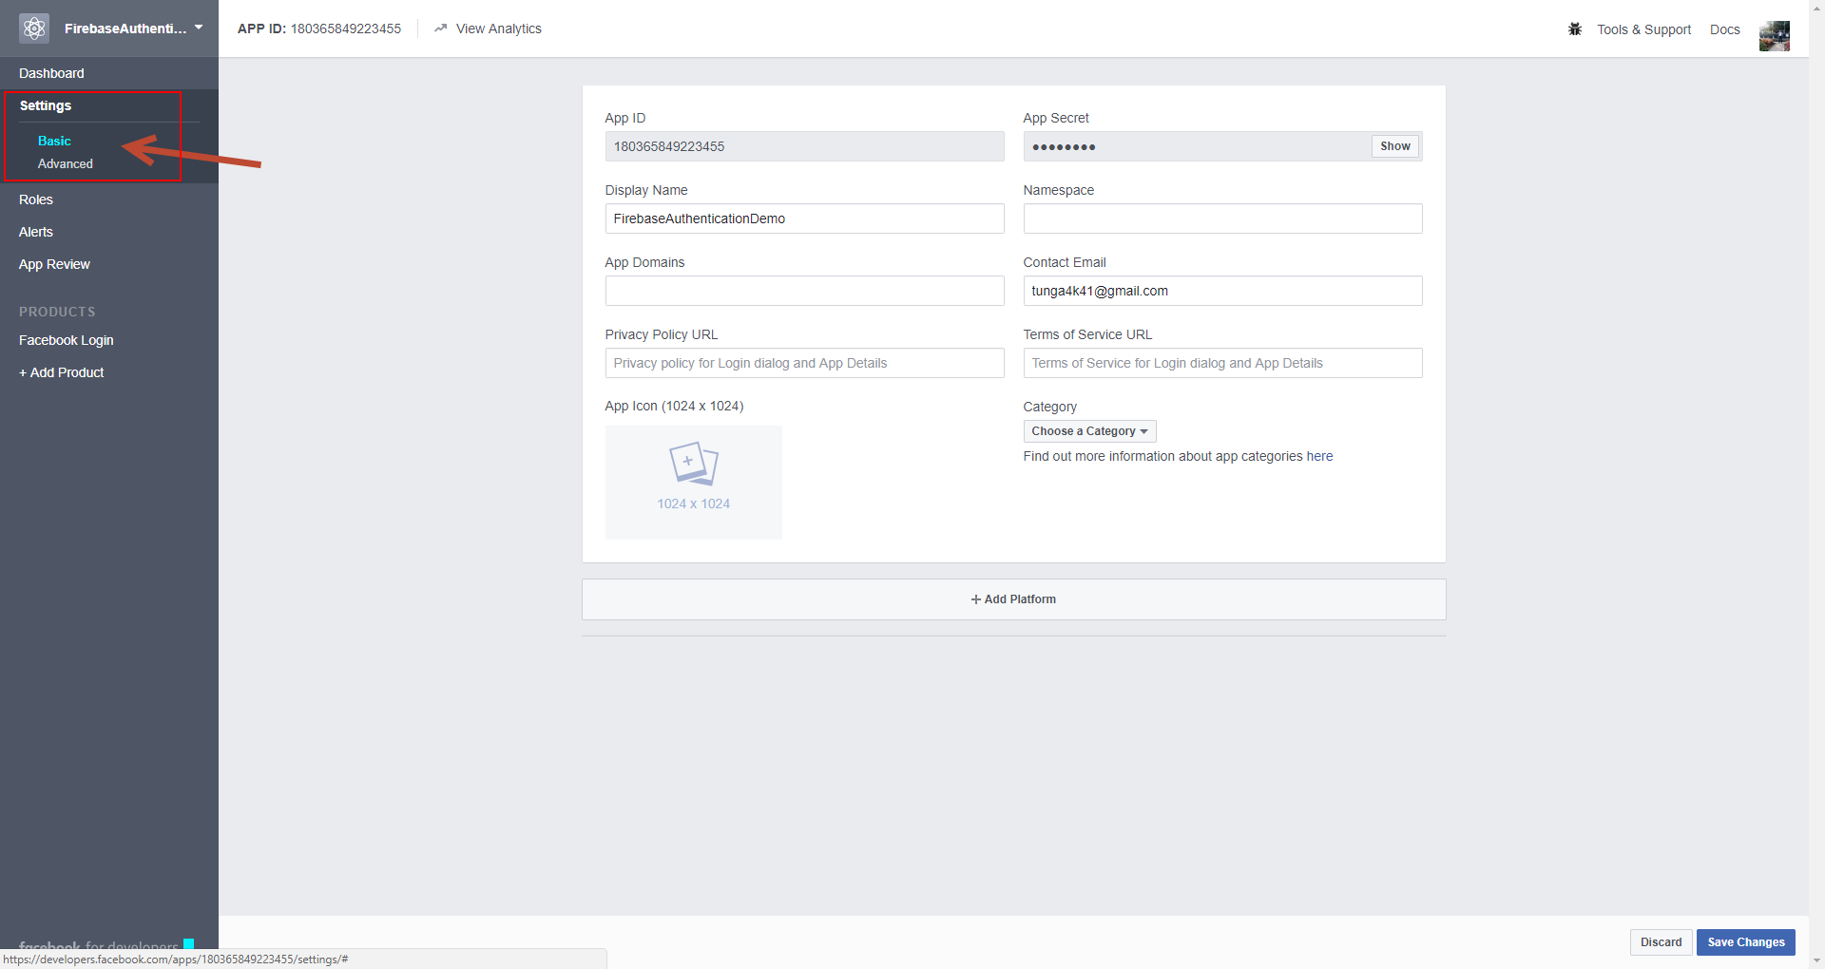

## **Setup for iOS**

Click **Add Platform and Select iOS.**

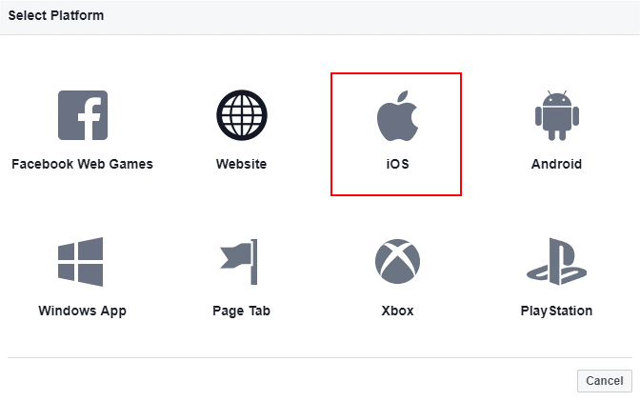

Make sure **Bundle ID** is inputted and **Enable features** as below image

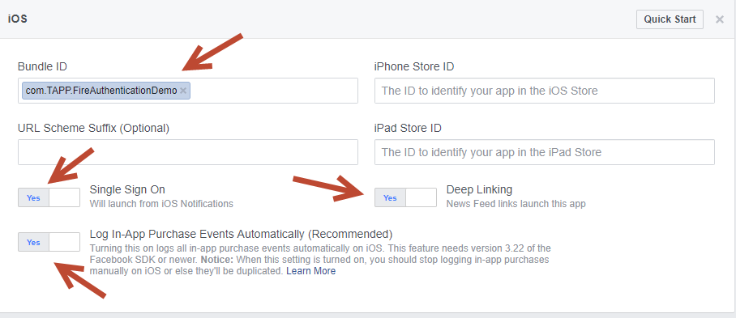

## **Setup for Android**

Click **Add Platform** andSelect **Android.**

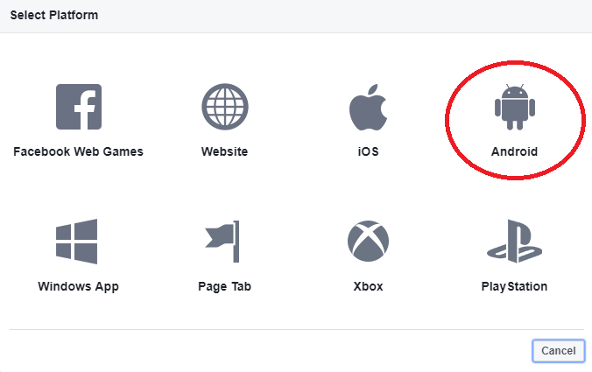

Copy **Package Name**, **Class Name**, **Key Hashes** from **Android Build Facebook Setting** to Android FB setting.

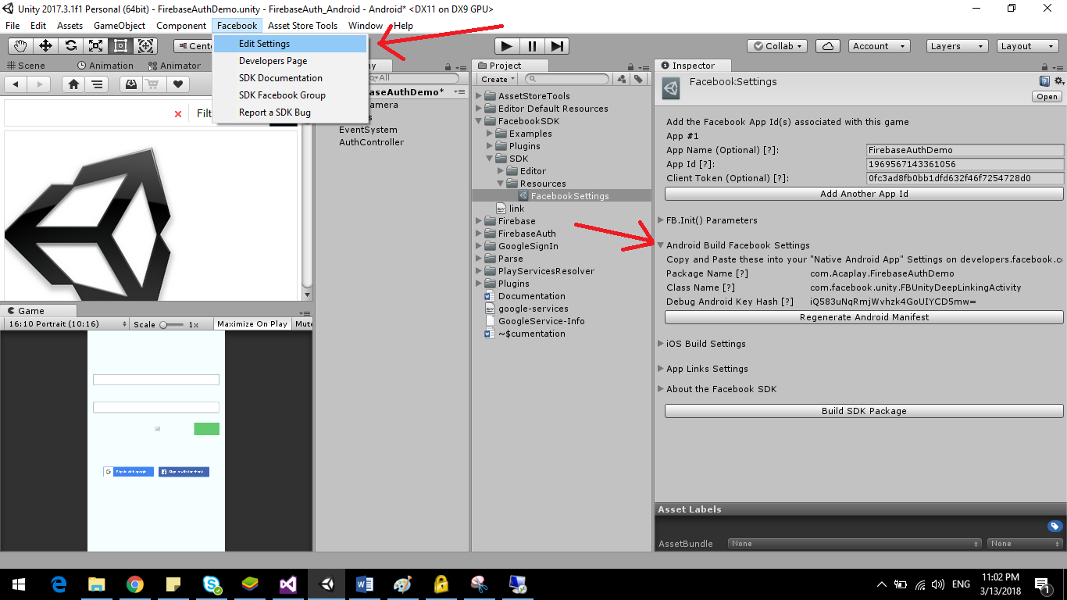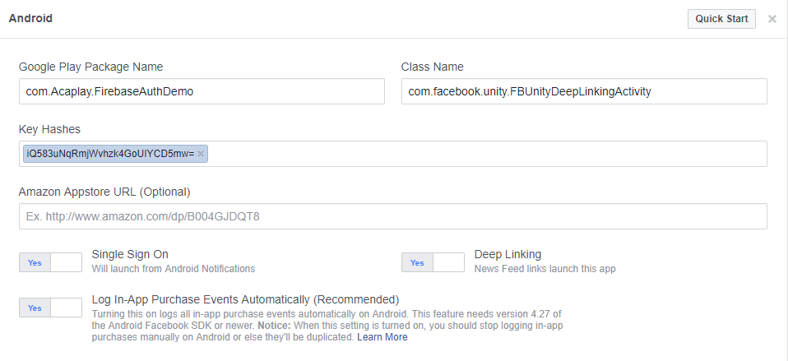

## **Notes**

* After losing info scandal, Facebook changed some rule and you will need to request permission to get info. Please refer <https://developers.facebook.com/docs/graph-api/reference/v3.0> to know what permission you need to request.
* When load profile image from firebase URL, I don’t know why now we can’t load image, so solution that I suggest as we will use image url from Facebook (not from Firebase), it work as well now.
* Beside, you also can setup something like icon, domain, etc. for your Facebook project.

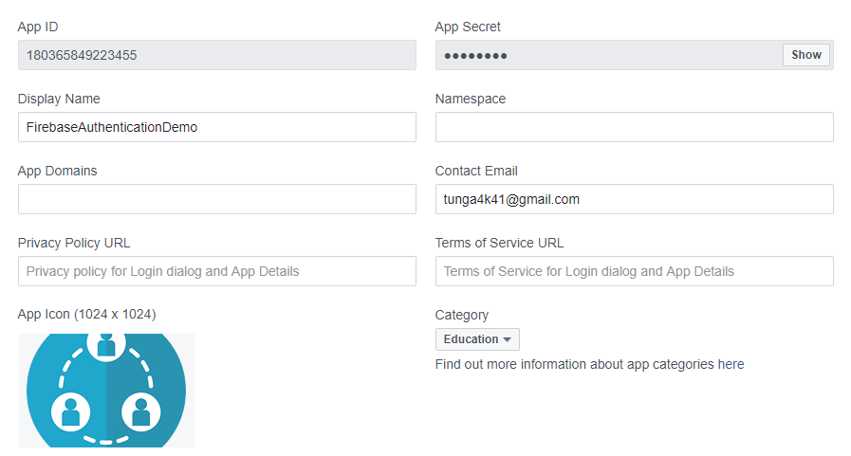

# **Twitter Setup (iOS and Android)**

## **Setup**

Go to <https://apps.twitter.com/> and create new project.

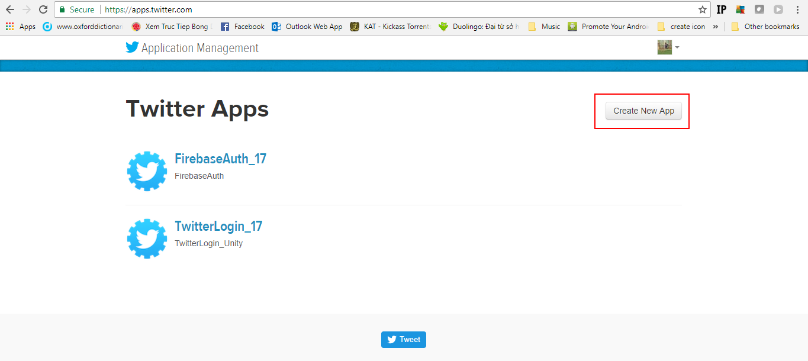

Input information to complete creating. Make sure **Callback URL** field is inputted (Callback URL get from Twitter Firebase setup).

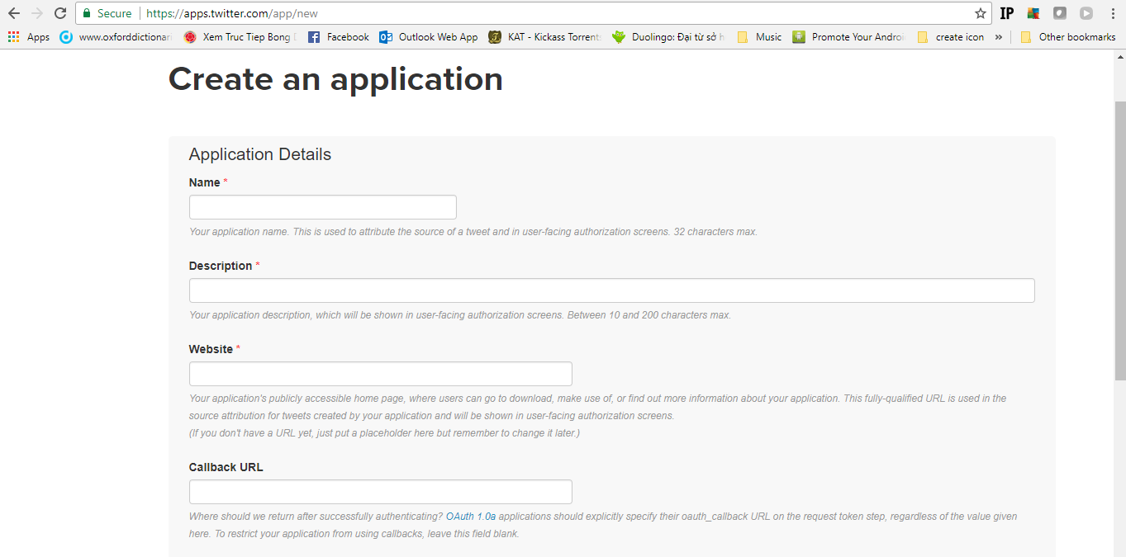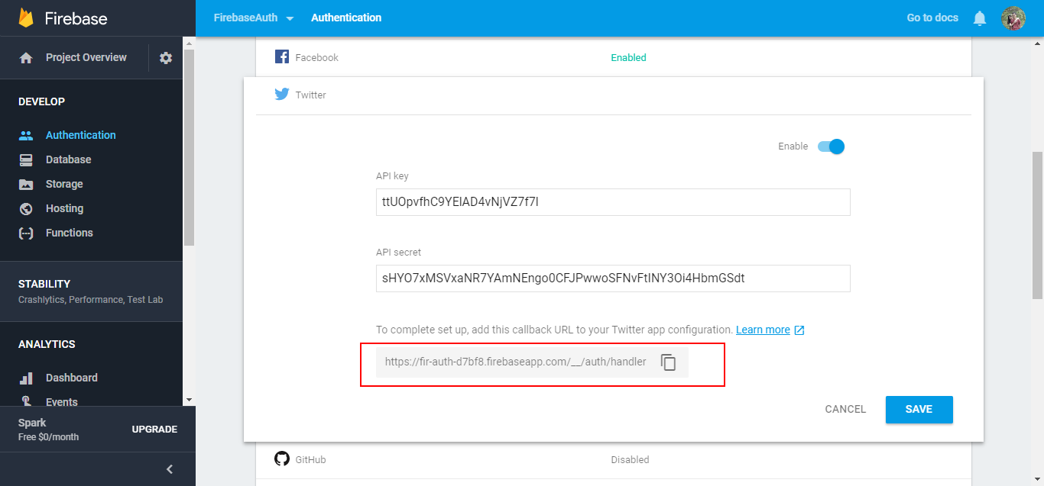

After created, the information is showed as bellow:

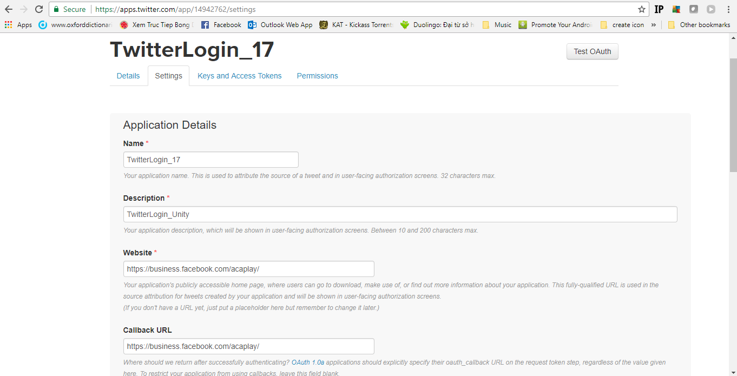

Go to **Keys and Access Tokens** tab to get **API Key, API Secret** to setting for Unity

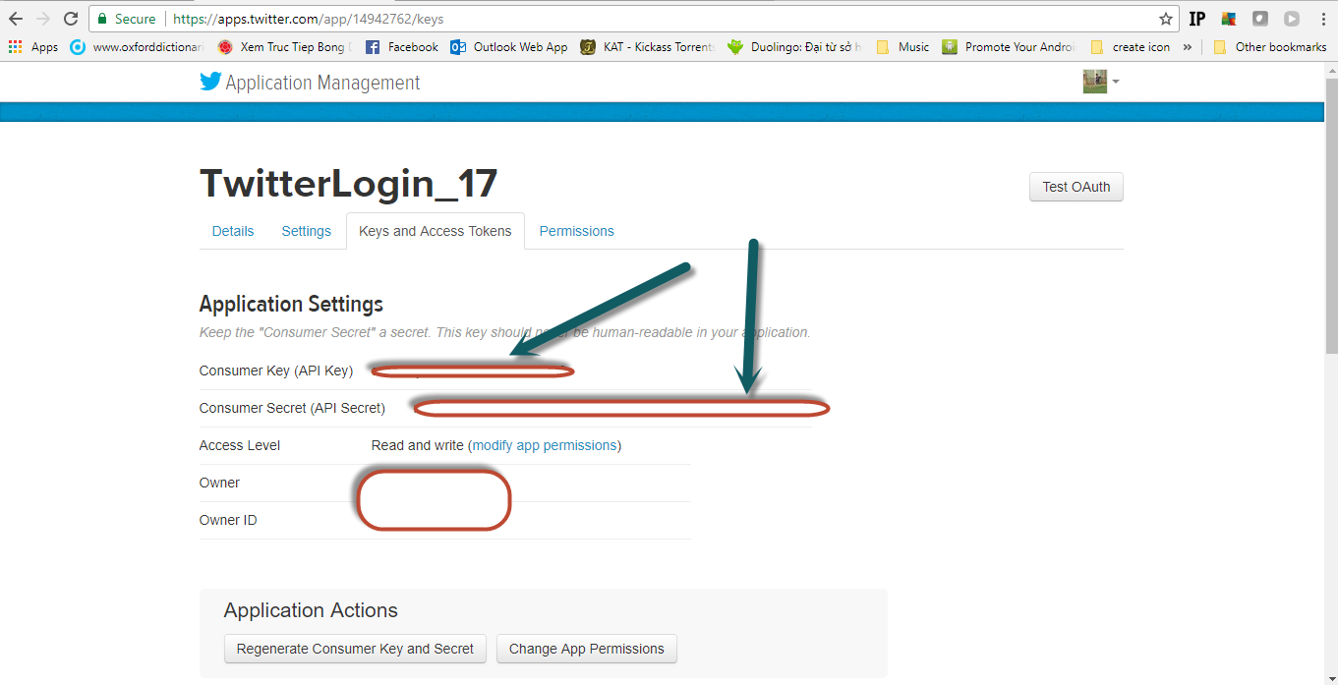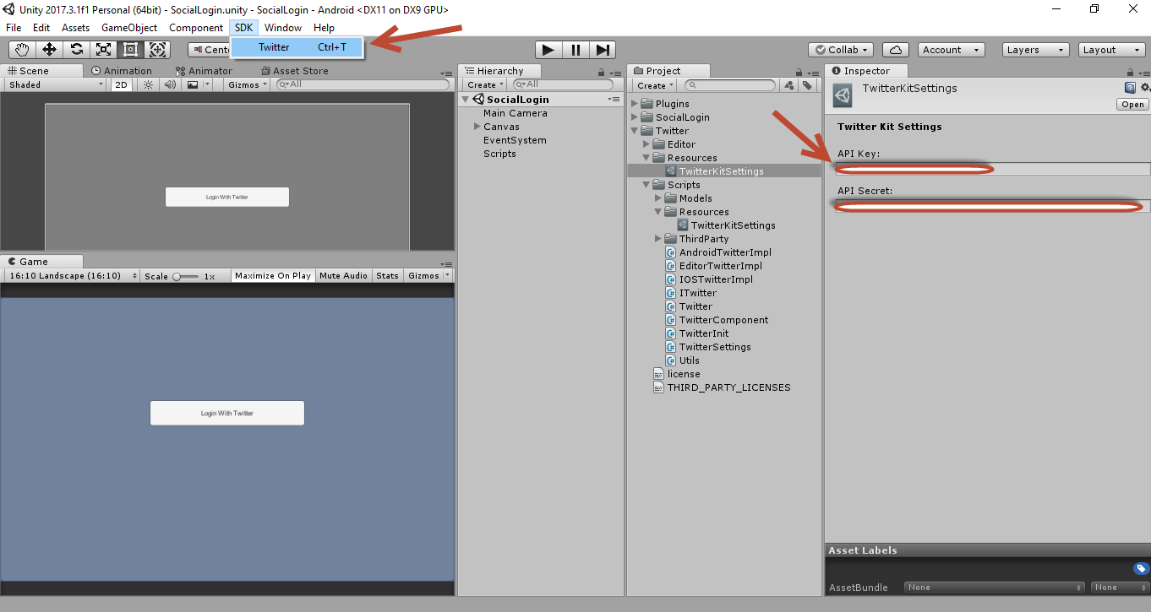

Done -> Build and Run

## **Note**

* Make sure Twitter is installed on your device because some time you will got crash app when click Twitter login.
* If you get error with phone number as bellow and you can’t input phone number to your profile, please use twitter mobile app to input your phone:

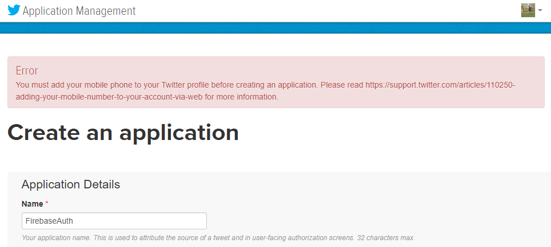

* Twitter Kit SDK require iOS 10.0 or higher.

# **Phone Setup**

## **Enable Phone Sign-In method**

To sign in users by SMS, you must first enable the Phone Number sign-in method for your Firebase project:

* In the [**Firebase Console**](https://console.firebase.google.com/), open the Authentication section.
* On the **Sign-in Method** page, enable the **Phone Number sign-in** method.

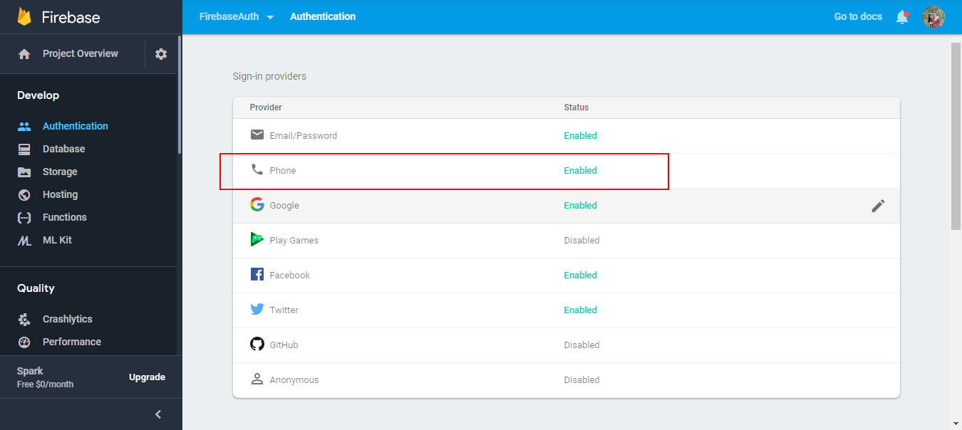

Also you can add phone number for testing, it means have no SMS message is sent to your phone, you will use the verification code that you setting to verify.

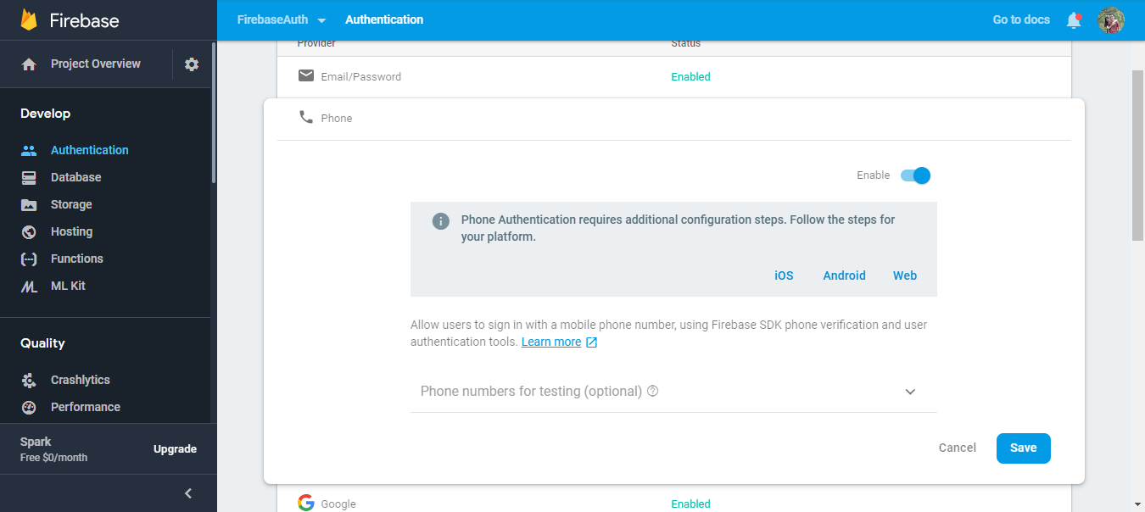

## **Setting** **APNs (iOS only)**

### **In Xcode, enable push notifications for your project.**

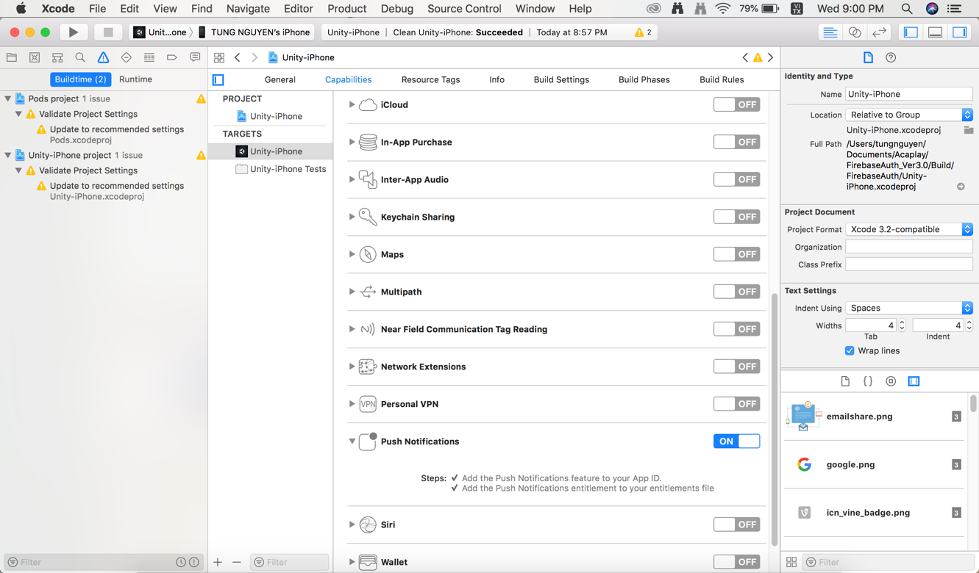

* + 1. **Create and upload APNs certificate to Firebase.**

**Create an App ID and Provisioning Profile** (refer <https://firebase.google.com/docs/cloud-messaging/ios/certs> )

* Please note just refer Create App ID and Provisioning Profile

**Create APNs certificate.** (refer <https://developer.clevertap.com/docs/how-to-create-an-ios-apns-certificate> )

**Upload APNs certificate.**

**Project Setting -> Cloud Message**

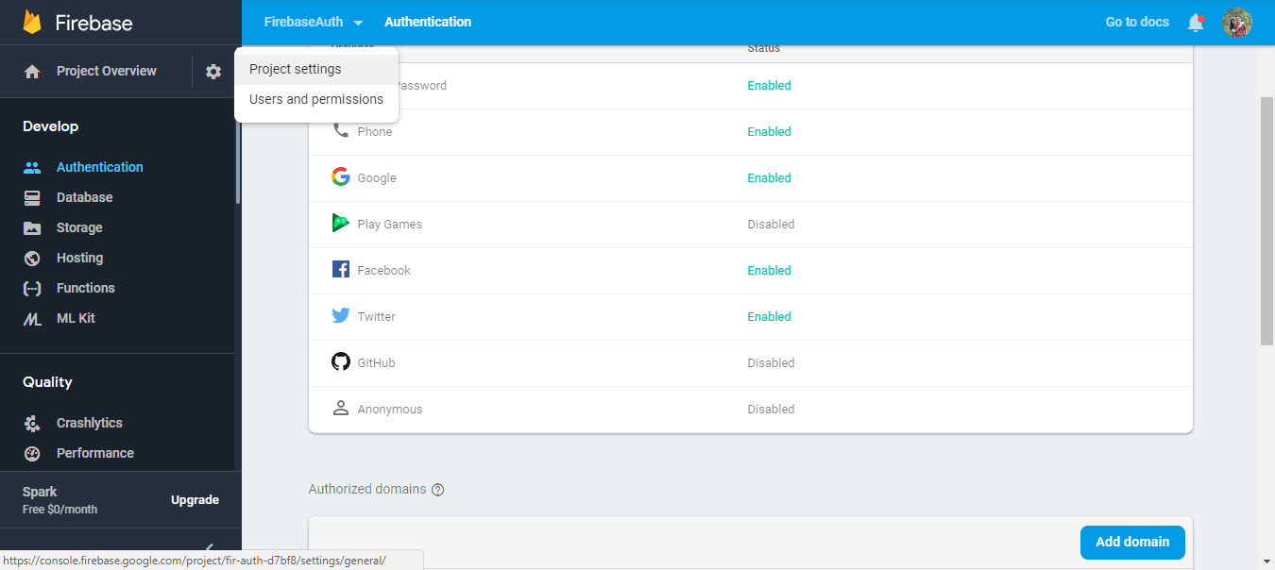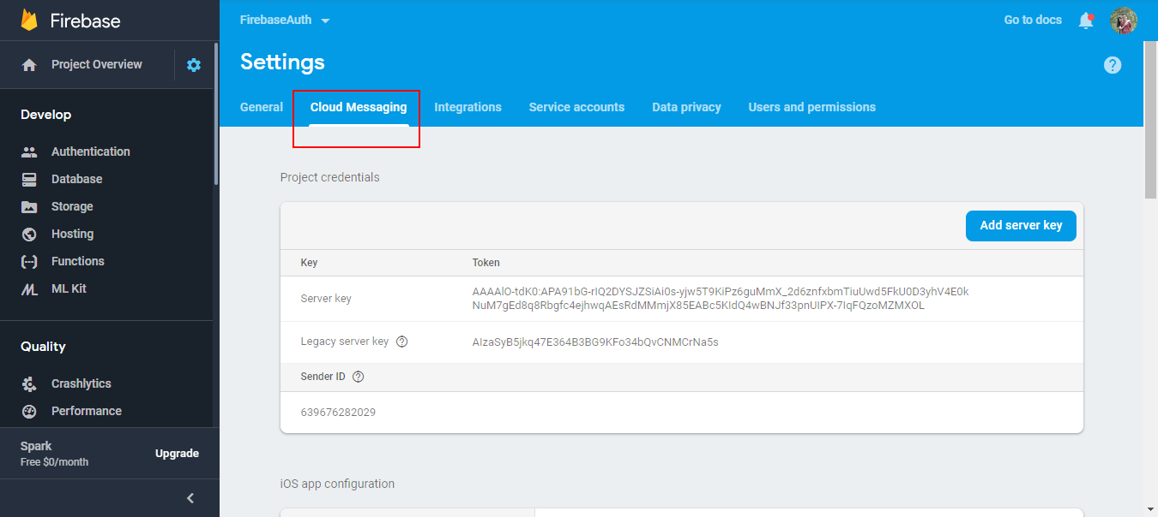

**Upload APNs certificate for both Production and Development (it depend on you)**

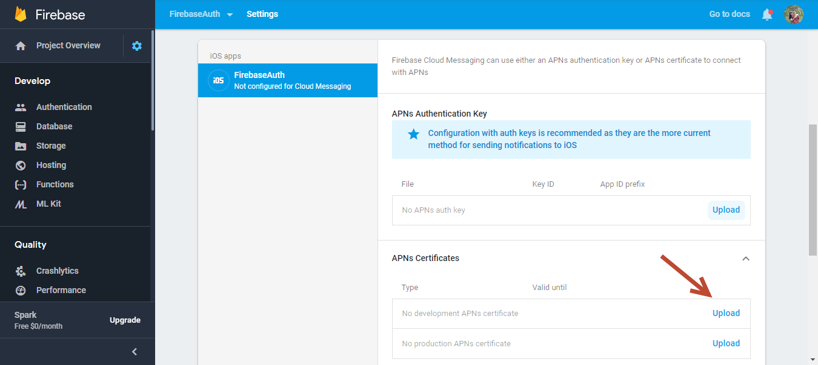

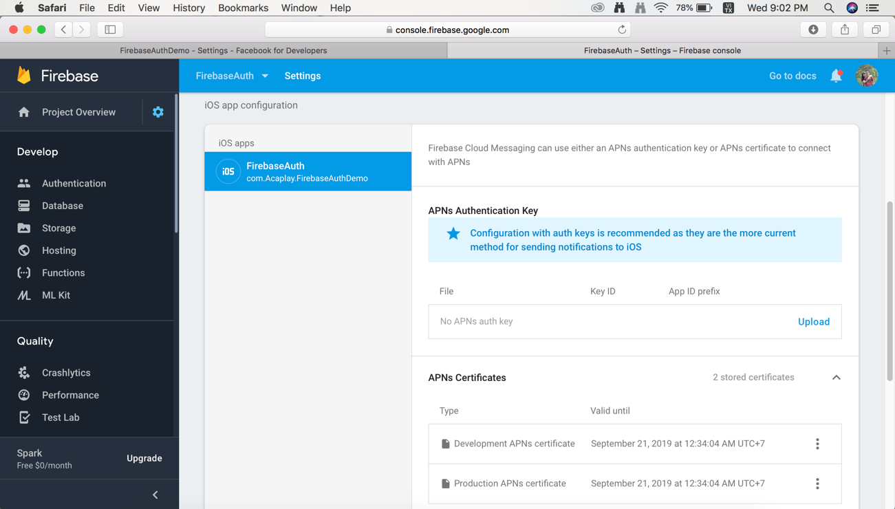

# **Download**

|  |  |
| --- | --- |
| Facebook SDK | <https://developers.facebook.com/docs/unity/downloads> |
| Google Sign-In | <https://github.com/googlesamples/google-signin-unity/releases> |
| Google Ads | <https://github.com/googleads/googleads-mobile-unity/releases> |
| Open SSL | <https://code.google.com/archive/p/openssl-for-windows/downloads> |
| Google Play Service | <https://github.com/playgameservices/play-games-plugin-for-unity/releases> |
| Policy Generator | <https://app-privacy-policy-generator.firebaseapp.com/> |